ALCOHOLS PHENOLS AND ETHERS

CHAPTER OVERVIEW
The chapter Alcohol, Phenol, and Ethers is a high-scoring and relatively easy part of Organic Chemistry for JEE Mains. It generally contributes one to two questions in the JEE Mains exam each year. This chapter is closely related to the previous chapter on Haloalkanes and Haloarenes, as many fundamental concepts like nucleophiles, carbocations, and rearrangements carry over.

CLASSIFICATION
I) BY NUMBER OF OH GROUPS
Alcohols and phenols are classified based on how many hydroxyl (OH) groups are present in the molecule.
1. Monohydric Alcohols: These contain only one OH group. A common example is ethanol.
2. Dihydric Alcohols: These contain two OH groups.
Examples :-
Ethylene glycol (Ethane-1,2-diol)
Catechol (1,2-dihydroxybenzene)
Resorcinol (1,3-dihydroxybenzene)
Quinone (1,4-dihydroxybenzene)
3. Polyhydric or Trihydric Alcohols: These contain more than two OH groups. Glycerin (Propane-1,2,3-triol) is a well-known trihydric alcohol.

II) BY HYBRIDIZATION
The classification is also based on whether the OH group is attached to an sp3 or sp2 hybridized carbon atom,.

CATEGORY 1: SP3 C-OH ALCOHOLS
The OH group is attached to an sp3 hybridized carbon. This is further divided into:
- 1 Degree (Primary) Alcohol: OH is attached to a primary carbon, such as in CH3CH2OH.
- 2 Degree (Secondary) Alcohol: OH is attached to a secondary carbon.
- 3 Degree (Tertiary) Alcohol: OH is attached to a tertiary carbon.
- Allylic Alcohol: OH is attached to an sp3 hybridized carbon that is directly adjacent to a carbon-carbon double bond.
- Benzylic Alcohol: OH is attached to an sp3 hybridized carbon that is directly attached to an aromatic benzene ring.

CATEGORY 2: SP2 C-OH ALCOHOLS AND PHENOLS
The OH group is attached to an sp2 hybridized carbon.
- Vinylic Alcohol: OH is attached directly to a carbon atom of a double bond (C=C), but that carbon is not part of an aromatic ring.
- Phenols: OH is attached directly to an sp2 hybridized carbon atom that is part of a benzene ring.

COMMON MISTAKES AND TRAPS
Mistake | Why Students Make It | Correct Approach / Thinking
Calling Benzylic Alcohol a Phenol | Both have benzene rings. | Check if OH is directly on the ring. If there is a carbon bridge, it is benzylic.
Vinylic as Aromatic | Both use sp2 carbons. | Vinylic refers to non-aromatic double bonds. Phenols refer to aromatic rings.
Missing Glycol/Glycerin Names | They focus on IUPAC and ignore common names. | Memorize Glycol (2 OH) and Glycerin (3 OH) as they are standard exam terms.

HIGH-YIELD REVISION SHEET
MUST REMEMBER
- Monohydric (1 OH), Dihydric (2 OH), Trihydric (3 OH),.
- Ethylene Glycol common name for Ethane-1,2-diol.
- Glycerin common name for Propane-1,2,3-triol.
- Catechol (ortho), Resorcinol (meta), Hydroquinone (para).
- Benzylic and Allylic carbons are sp3 hybridized.
- Vinylic and Phenolic carbons are sp2 hybridized.
LAST-MINUTE REVISION POINTS
- Phenol: OH is directly on the benzene ring.
- Benzylic Alcohol: OH is on a carbon attached to the ring.
- Allylic Alcohol: OH-C-C=C.
- Vinylic Alcohol: OH-C=C.
- The degree (1/2/3) depends on the carbon holding the OH group.
--------------------------------------------------------------------------------

NATURE OF THE FUNCTIONAL GROUP
BOND ANGLE
The geometry around the oxygen atom is tetrahedral.
- Ideal Tetrahedral Angle: 109.5 degrees (or 109 degrees 28 minutes).
- Actual Bond Angle: In alcohols, the C-O-H bond angle is slightly less than 109.5 degrees.
- Reasoning: According to VSEPR theory, lone pair-bond pair (LP-BP) repulsion is stronger than bond pair-bond pair (BP-BP) repulsion. The two lone pairs on oxygen repel the C-O and O-H bonding pairs, pushing them closer together and decreasing the angle.

BOND LENGTH COMPARISON
There is a significant difference between the Carbon-Oxygen (C-O) bond lengths in Methanol and Phenol.
- Observation: The C-O bond length in Phenol is shorter than the C-O bond length in Methanol.
- Reason 1 (Resonance): In phenol, one of the lone pairs on the oxygen atom is in resonance with the pi-system of the benzene ring. This introduces partial double bond character to the C-O bond, which increases bond strength and decreases bond length.
- Reason 2 (Hybridization): In methanol, the oxygen is attached to an sp3 hybridized carbon. In phenol, the oxygen is attached to an sp2 hybridized carbon of the benzene ring. sp2 hybridized carbons have more s-character (33 percent vs 25 percent), making them more electronegative and capable of holding the oxygen more tightly, thus shortening the bond.
# This explains why phenols do not easily undergo nucleophilic substitution reactions.

NOMENCLATURE BASICS
Standard IUPAC naming conventions for alcohols involve:
- Suffix: -ol (e.g., Ethanol, Methanol).
- Prefix: hydroxy- (used when the hydroxyl group is treated as a substituent rather than the principal functional group).

HIGH-YIELD REVISION SHEET
MUST REMEMBER
- Alcohol bond angle: Less than 109.5 degrees due to LP-BP repulsion.
- Phenol C-O bond: Shorter than methanol due to resonance and sp2 carbon.
- Suffix: -ol.
- Prefix: hydroxy-.

LAST-MINUTE REVISION POINTS
- LP-LP > LP-BP > BP-BP is the repulsion order affecting the angle.
- Resonance in phenol gives partial double bond character.
- sp2 carbon in phenol is more electronegative than sp3 carbon in methanol.
- The C-O bond in phenol is stronger and shorter than in methanol.
--------------------------------------------------------------------------------

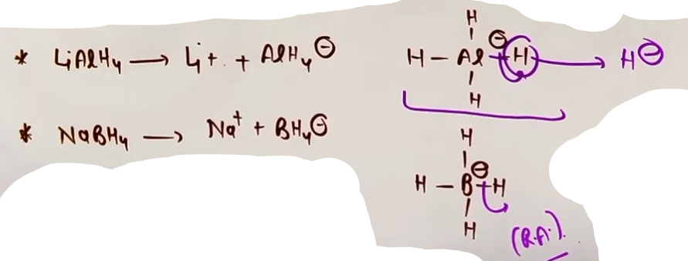
Why LiAlH4 and NaBH4 act as reducing agent?
- metals k tendency hoti h electron lose karne ki (+ve) charge rakhne ki nake (-ve) charge ki isliye jab uspe (-ve) charge aaya toh vo bhaura utha aur H- lose kar diya.
--------------------------------------------------------------------------------

METHODS OF PREPARATION (MOP) OF ALCOHOLS

REACTION 1: FROM ALKYL HALIDES (NUCLEOPHILIC SUBSTITUTION)
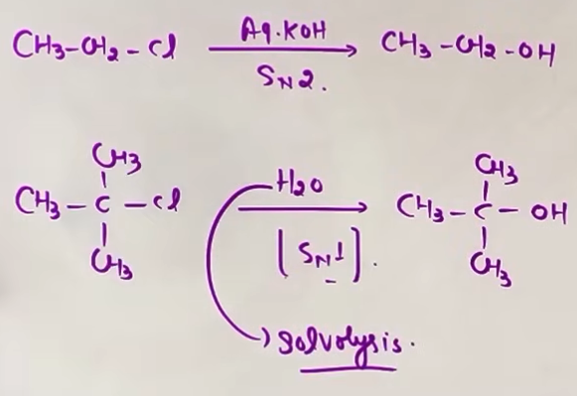
Alcohols can be prepared from alkyl halides through hydrolysis using aqueous bases or water.
- Reagents: Aqueous KOH, aqueous NaOH, or moist Ag2O.
- Mechanism: Depends on the degree of the alkyl halide.
- 1-degree Alkyl Halides: Follow SN2 mechanism.
- 3-degree Alkyl Halides: Follow SN1 mechanism. This often occurs via solvolysis with water.

REACTION 2: ACID-CATALYZED HYDRATION OF ALKENES
This is the addition of water to alkenes in the presence of an acid catalyst.
- Reagents: H2O / H+ (dilute H2SO4).
- Intermediate: Carbocation.
- Mechanism:
1. Protonation of alkene to form a carbocation (Slow step/RDS).
2. Nucleophilic attack by water.
3. Deprotonation to form alcohol.
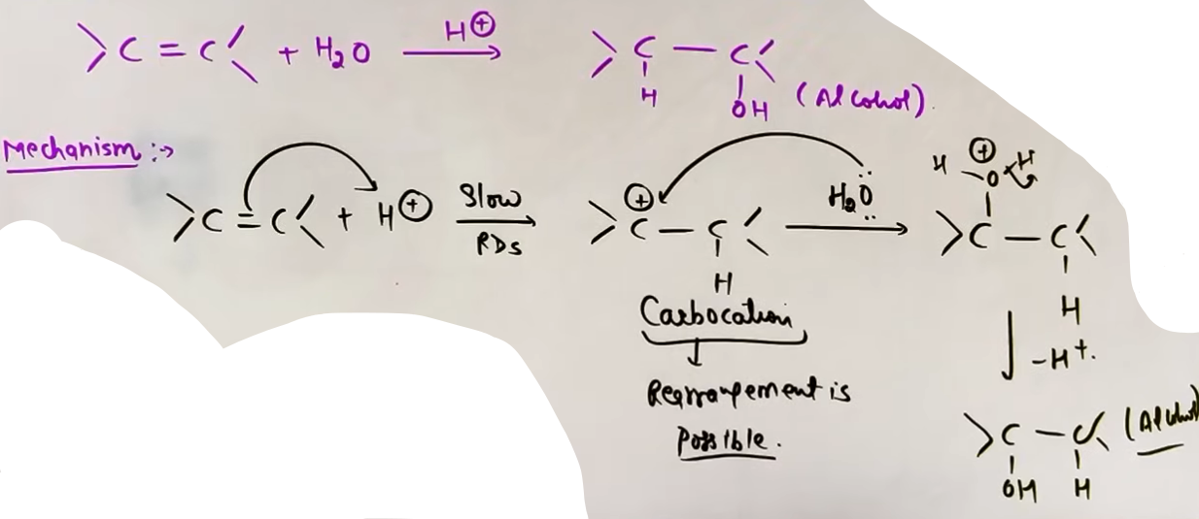
- Special Case: Since a carbocation is formed, rearrangements (hydride shift, methyl shift, or ring expansion) are possible to achieve a more stable intermediate.

# sirf Markovnikov's Rule se jaoge toh nipat jaoge lala, mechanism se karengo toh gach jouge.

REACTION 3: HYDROBORATION-OXIDATION (HBO)
A two-step method to convert alkenes to alcohols.
- Reagents: 1. B2H6 (or BH3-THF), 2. H2O2 / OH-.
- Result: Addition of H2O according to Anti-Markovnikov's Rule.
- Stereochemistry: Syn-addition (H and OH add to the same side).
- Key Feature: No rearrangements occur because the reaction proceeds through a four-membered cyclic transition state, not a free carbocation.
# BH3 stable nahi h isliye vo dimerise hoke B2H6 banata h.
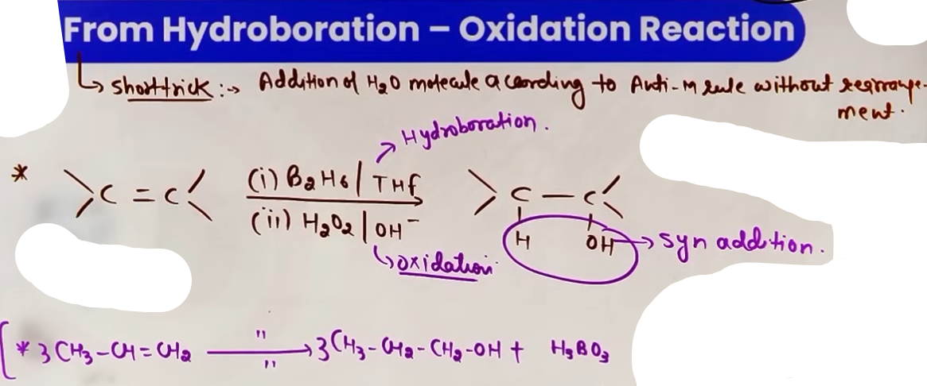
---
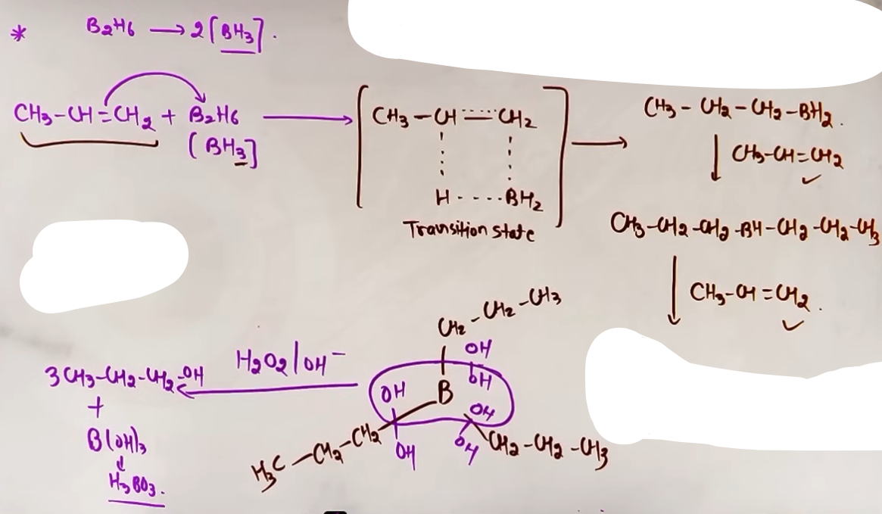Mechanism
# step one m BH3 k saare hydrogen ki jagah alkyl group lagta h fir step two m H2O2 tot k ek OH B ko aur ek OH baki alkyl group ko deta h.
# one mole BH3 k sath 3 mole alkene lene hote h.
# iske question m seedhe short trick (adding of H2O acc. to Anti-Markonikov rule) lagao ge toh bhi kaam ho jayga.

REACTION 4: OXYMERCURATION-DEMERCURATION (OMDM) REACTION
A two-step hydration process, first step is oxymercuration and second is demercuration.
- Reagents: 1. Hg(OAc)2 / H2O, 2. NaBH4 / OH-.
- Result: Addition of H2O according to Markovnikov's Rule.
- Key Feature: No rearrangements occur because it involves a Non-Classical Carbocation (3-membered mercurinium ion ring).
- Stereochemistry: Anti-addition.
- Note: The OH group comes from H2O, and the H comes from the reducing agent (NaBH4).
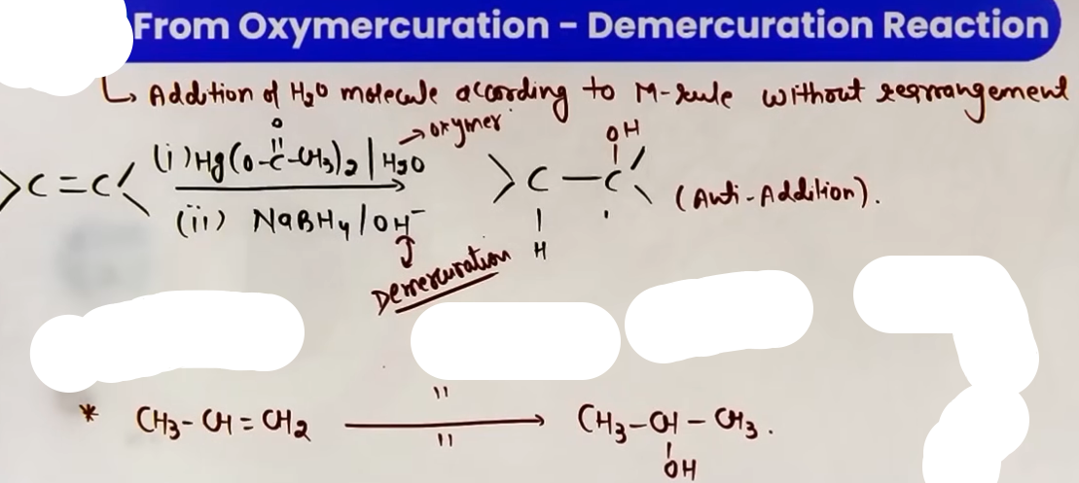
---
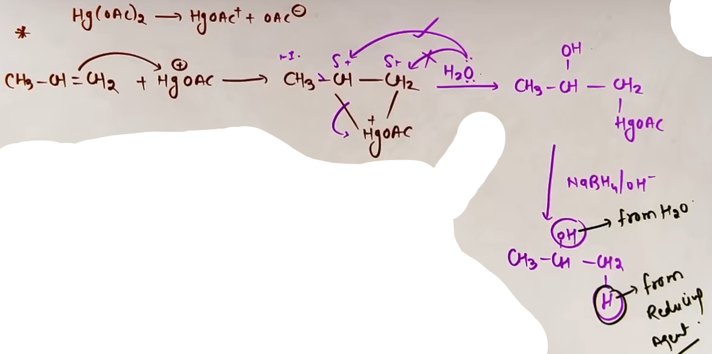
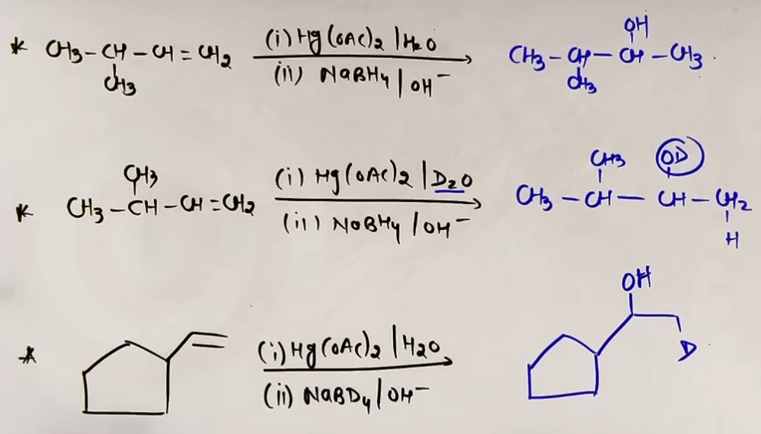# seedhe markonikov's rule k according H2O add kar do kaafi h aur OH water se aayega aur H reducing agent se.
REACTION 5: REDUCTION OF CARBONYL COMPOUNDS
Converting aldehydes and ketones into alcohols.
- Reagents: NaBH4, LiAlH4, or H2 Ni/Pt/Pd (catalytic).
- 1-degree Alcohols: Produced from the reduction of Aldehydes (R-CHO).
- 2-degree Alcohols: Produced from the reduction of Ketones (R-CO-R).
- Selectivity: LiAlH4 is stronger and more expensive. NaBH4 is milder and preferred for simple carbonyl reduction as it does not react with moisture as violently as LiAlH4.
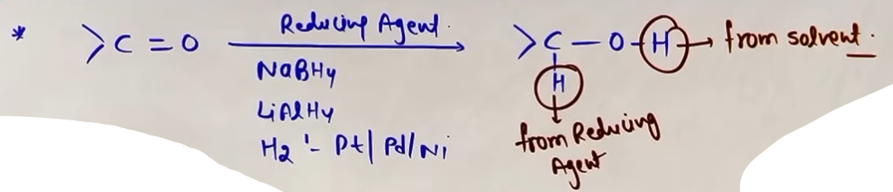
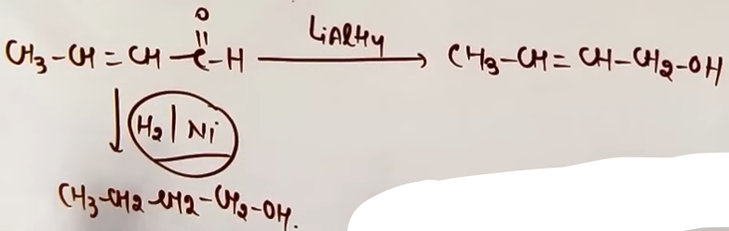
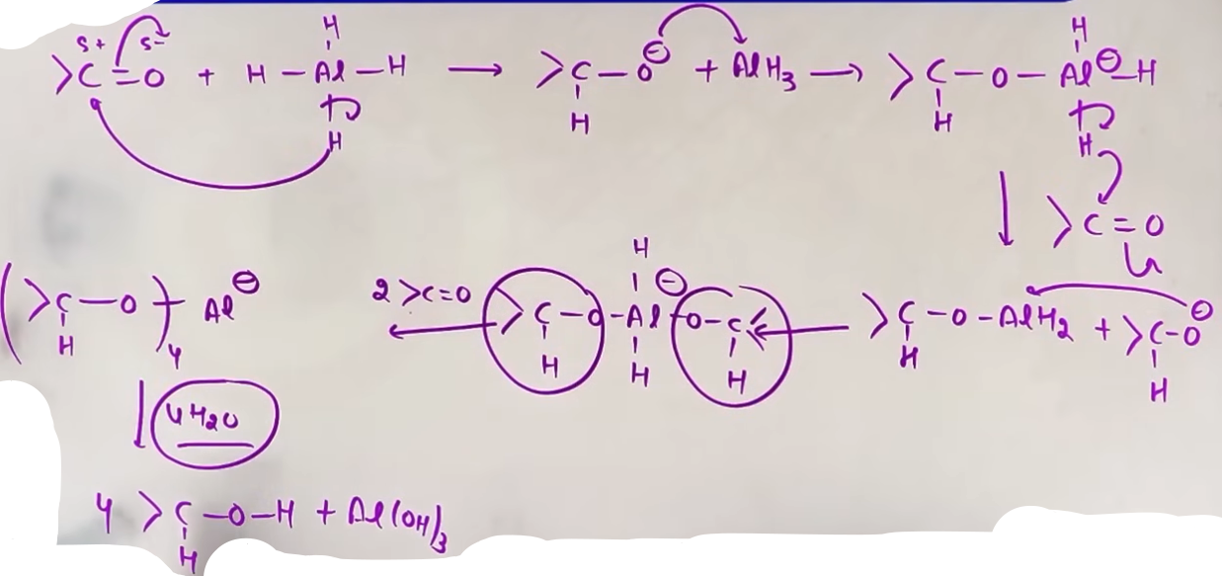# mechanism , iski utni zarurat nahi :)
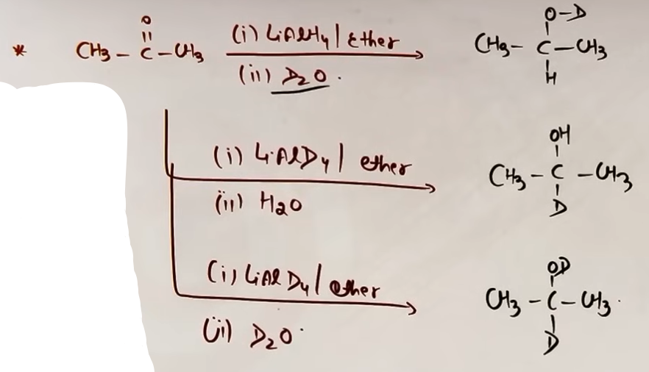
REACTION 6: FROM GRIGNARD REAGENT (RMgX)
Adding alkyl groups to carbonyls to build alcohols.
- Reagents: 1. RMgX / Dry Ether, 2. H3O+.
- Formaldehyde (HCHO) + RMgX -> 1-degree Alcohol.
- Other Aldehydes (RCHO) + RMgX -> 2-degree Alcohol.
- Ketones (RCOR) + RMgX -> 3-degree Alcohol.
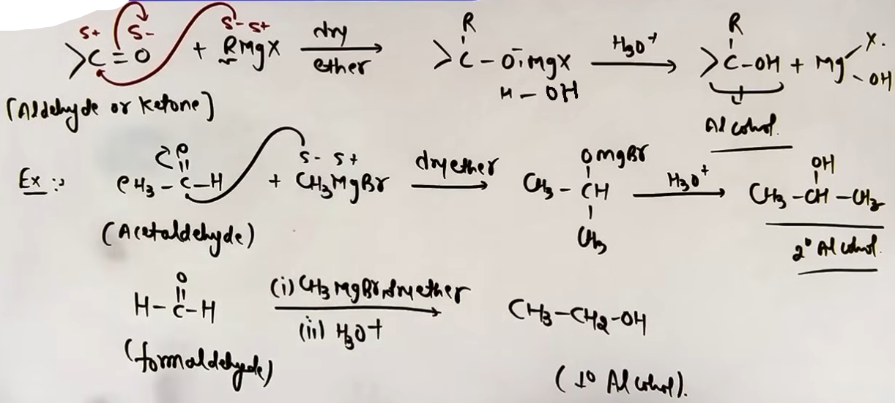
REACTION 7: REDUCTION OF CARBOXYLIC ACIDS AND DERIVATIVES {Acid halide, Ester, Acid Anhydride}
Converting acids and esters to alcohols.
- Reagents: LiAlH4 is the primary reagent.
- 1-degree Alcohols: Produced from Acids, Acid Chlorides, Esters, and Anhydrides.
- Note: NaBH4 cannot reduce Carboxylic Acids, Esters or Acid Anhydride; it only works on Acid Chlorides within this category.
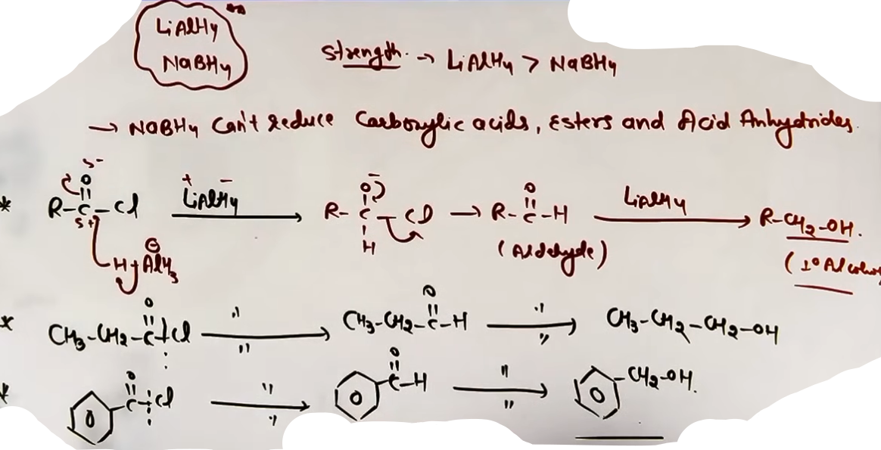# Cl ko hataya uski jagah H lagaya fir pichli rxn hi to h.
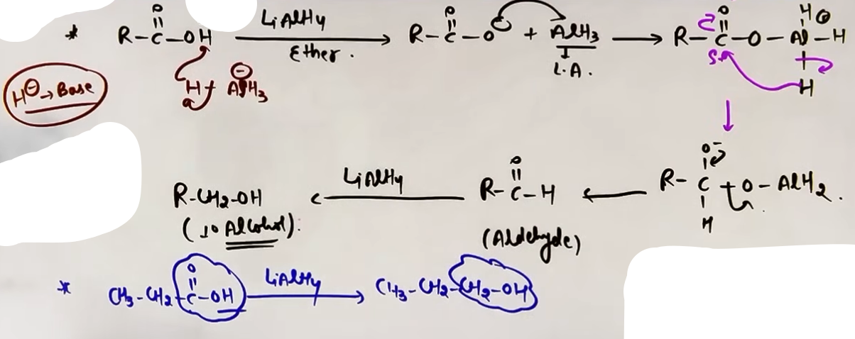Figure 1: seedhe short trick se kar sakte h -COOH ki jagah -CH2OH laga do.
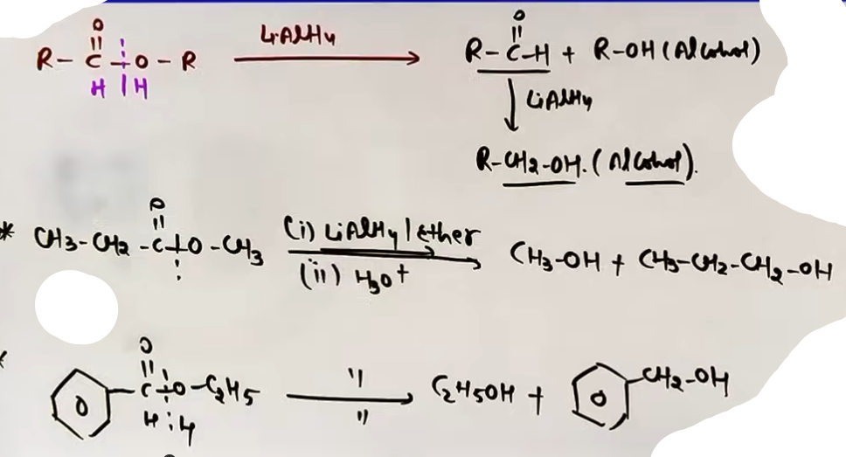# CO-O bond toro dono ko H de do fir aldehyde k pichle ke pichle ki tarah alcohol bana do.

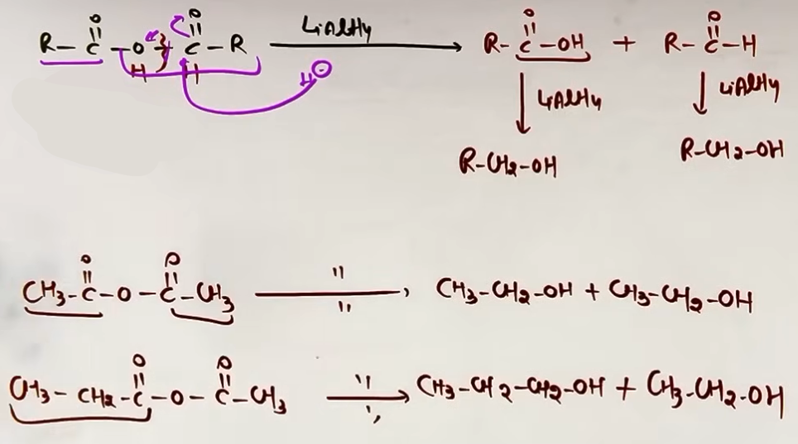# koi bhi ek C-O bond tar kar dono ko H dedo ek acid aur aldehyde milega aur aageka toh pehle kar liya h.
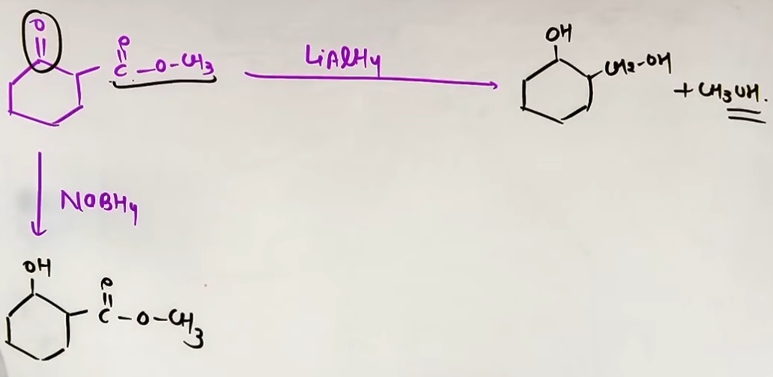# NaBH4 acid ko toh reduce nahi kar payega par ketone ko kar dega aur LiAlH4 kisipe raham nhi khayega.
MENTAL MODEL FOR CARBONYL REDUCTION
Think of the C=O bond as a door. The reducing agent provides a "Hydride Key" (H-) that opens the door by attacking the carbon. The solvent then provides a "Proton Hat" (H+) for the oxygen to complete the alcohol.

FORMULA SHEET
Starting Material | Reagent | Rule/Mechanism | Product
Alkene | H2O/H+ | Markovnikov + Rearrange | Alcohol
Alkene | HBO | Anti-Markovnikov | Alcohol
Alkene | OMDM | Markovnikov (No Rearrange) | Alcohol
Aldehyde | NaBH4/LiAlH4 | Reduction | 1-deg Alcohol
Ketone | NaBH4/LiAlH4 | Reduction | 2-deg Alcohol
Formaldehyde | RMgX | Grignard Addition | 1-deg Alcohol
Acid/Ester | LiAlH4 | Reduction | 1-deg Alcohol

CONCEPT CONNECTIONS
- GOC: Carbocation stability (3 deg > 2 deg > 1 deg) dictates the rate of Acid-Catalyzed Hydration.
- HYDROCARBONS: These reactions are the bridge between alkenes/alkynes and oxygen-containing functional groups.
- HALOALKANES: SN1 and SN2 mechanisms from the previous chapter are directly applied to the preparation from alkyl halides.

EXAMPLES AND APPLICATIONS
EXAMPLE 1: ACID HYDRATION OF 3,3-DIMETHYLBUT-1-ENE
1. Protonation forms a 2-degree carbocation.
2. Methyl shift occurs to form a more stable 3-degree carbocation.
3. OH attacks the 3-degree carbon.
Result: 2,3-Dimethylbutan-2-ol.

EXAMPLE 2: OMDM ON 3,3-DIMETHYLBUT-1-ENE
1. Mercurinium ion forms.
2. No shift is possible.
3. OH attacks the 2-degree carbon.
Result: 3,3-Dimethylbutan-2-ol (Markovnikov product without rearrangement).

EXAMPLE 3: REDUCTION OF AN UNSATURATED ALDEHYDE (CH3-CH=CH-CHO)
- With LiAlH4 or NaBH4: The C=C remains. Product is CH3-CH=CH-CH2OH.
- With H2/Ni: Both C=C and C=O reduce. Product is CH3-CH2-CH2-CH2OH.

COMMON MISTAKES AND TRAPS
Mistake | Why Students Make It | Correct Approach / Thinking
Rearranging in HBO, thinking all alkene | HBO uses a transition state, hydrations rearrange. | not a cation. No shifts!
NaBH4 with Acids | Forgetting strength. | NaBH4 is too weak for acids/esters. Use LiAlH4.
Water with Grignard | Basicity vs Nucleophilicity. | RMgX + H2O = Alkane. Use Dry Ether only.
Ignoring Syn/Anti | Forgetting 3D structure. | HBO is Syn; OMDM is Anti. Crucial for rings.

HIGH-YIELD REVISION SHEET
MUST REMEMBER:
- H+/H2O: Markovnikov + Rearrangement.
- HBO: Anti-Markovnikov + Syn-addition. No Rearrangement.
- OMDM: Markovnikov + Anti-addition. No Rearrangement.
- NaBH4: Reduces C=O to OH. Ignores Esters/Acids.
- LiAlH4: Reduces C=O, Acids, and Esters to OH.
- HCHO + RMgX = 1-degree Alcohol.
- RCHO + RMgX = 2-degree Alcohol.
- RCOR + RMgX = 3-degree Alcohol.

LAST-MINUTE REVISION POINTS:
- Check for ring expansion in Acid-Catalyzed Hydration.
- NaBH4 is mild; LiAlH4 is aggressive.
- H2/Ni reduces C=C; LiAlH4/NaBH4 usually do not.
- 3-degree alcohols cannot be made by simple oxidation but can be made by Grignard + Ketone.

--------------------------------------------------------------------------------

METHODS OF PREPARATION (MOP) OF PHENOLS

REACTION 1: DOWS PROCESS (FROM ARYL HALIDES)
This is a nucleophilic aromatic substitution reaction used to convert chlorobenzene into phenol. ♔ qs aaya h conditions pe !!
Reagents and Conditions: Chlorobenzene is treated with aqueous NaOH at 623 K temperature and 300 ATM pressure.
Process:
Step 1: Reaction with NaOH under drastic conditions forms sodium phenoxide.
Step 2: Acidification (treatment with H plus) of sodium phenoxide yields Phenol.
Reasoning: Aryl halides are normally unreactive toward nucleophilic substitution due to partial double bond character in the C-Cl bond; hence, high temperature and pressure are mandatory.
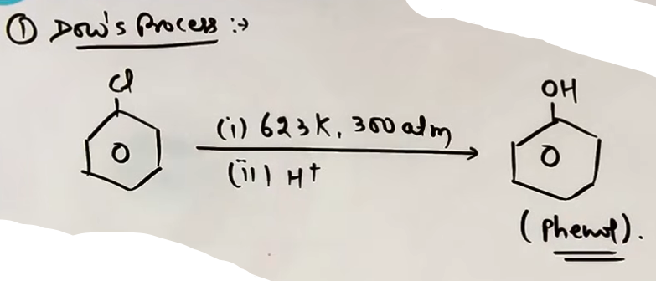
REACTION 2: FROM BENZENE SULPHONIC ACID
This method links benzene directly to phenol through sulphonation.
Step 1: (Sulphonation): Benzene reacts with concentrated H2SO4 or Oleum (H2S2O7) to form Benzene Sulphonic Acid (C6H5-SO3H). This is an Electrophilic Aromatic Substitution (EAS) reaction.
Step 2: (Fusion): The benzene sulphonic acid is treated with molten NaOH. This involves an acid-base reaction followed by fusion to form sodium phenoxide.
Step 3: (Acidification): Treatment with dilute acid (H plus) converts the sodium phenoxide into Phenol.
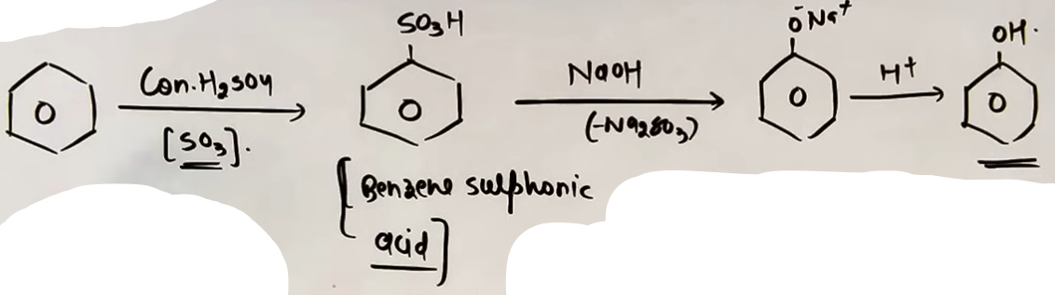
REACTION 3: FROM BENZENE DIAZONIUM SALT
This is a very convenient laboratory method starting from aniline.
Step 1: (Diazotization): Aniline (C6H5NH2) is treated with NaNO2 and HCl at 0 to 5 ᵒC to form Benzene Diazonium Chloride (C6H5-N2Cl).
Step 2: (Hydrolysis): The diazonium salt is warmed with water or treated with steam.
Result: The N2 group is replaced by an OH group, releasing Nitrogen gas and HCl as byproducts.

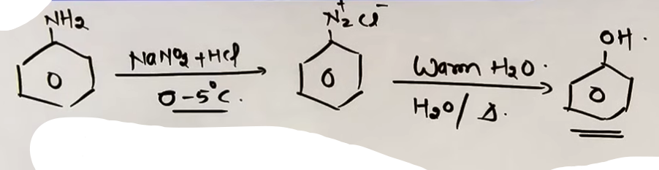
REACTION 4: FROM CUMENE (COMMERCIAL METHOD) ♔ question aaya h ispe !!
This is the most common industrial method for producing phenol globally.
Starting Material: Cumene, which is Isopropyl Benzene.
Step 1: (Oxidation): Cumene is oxidized in the presence of air (O2) to form Cumene Hydroperoxide. Oxygen inserts itself into the benzylic C-H bond.
Step 2: (Hydrolysis/Cleavage): Cumene hydroperoxide is treated with dilute acid (H+).
Outcome: It decomposes to produce Phenol and Acetone.

Economic Importance: This method is highly favored because it yields Acetone as a valuable byproduct in high quantities.
# dono hath ladoo
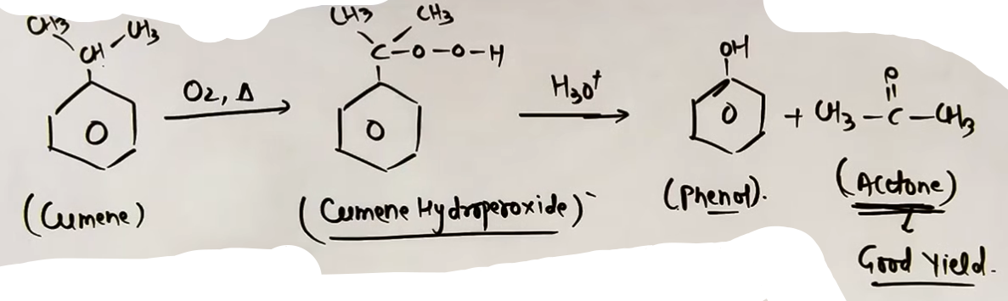
FORMULA SHEET
Starting Material | Reagents | Intermediate | Final Product
Chlorobenzene | NaOH, 623K, 300 ATM | Sodium Phenoxide | Phenol
Benzene | 1.Oleum 2.NaOH 3.H+ | C6H5-SO3H | Phenol
Aniline | 1.NaNO2/HCl 2.Warm H2O | C6H5N2Cl | Phenol
Cumene | 1. O2 2. H+ | Cumene Hydroperox. | Phenol plus Acetone

CONCEPT CONNECTIONS
- GOC: The acidity of Phenol (C6H5OH) is higher than that of aliphatic alcohols because the phenoxide ion is resonance-stabilized.
{phenol is weakly acidic, more acidic than alcohol and water ♔ qs aaya h ispe!!}
- Haloalkanes/Haloarenes: Dows process is a direct application of nucleophilic aromatic substitution studied in the previous chapter.
JEE ADVANCED INSIGHTS
- Intermediate in Cumene Process: The oxidation of cumene involves a free radical mechanism at the benzylic position, which is why it is specific to isopropyl benzene.
- Diazonium Salt Stability: The benzene diazonium salt is only stable at low temperatures (0 to 5 C). If the temperature rises during diazotization, it will decompose to phenol prematurely.
- Nucleophilic Substitution: In Dows process, the presence of electron-withdrawing groups (like -NO2) at ortho or para positions significantly lowers the temperature and pressure required for the reaction.

HIGH-YIELD REVISION SHEET
MUST REMEMBER:
- Commercial Method: Cumene (Isopropyl benzene) plus O2 plus H plus -> Phenol plus Acetone.
- Dows Process: Chlorobenzene plus NaOH (623K, 300 ATM) -> Phenol.
- Diazonium Route: Aniline -> NaNO2/HCl (0-5 C) -> C6H5N2Cl -> Warm H2O -> Phenol.
- Sulphonic Acid Route: Benzene -> Oleum -> C6H5SO3H -> NaOH/Fusion -> Phenol.

LAST-MINUTE REVISION POINTS:
- Acetone yield in the cumene process is high, making it economically viable.
- Phenol has a shorter C-O bond than methanol due to resonance and sp2 hybridization of carbon.
- Only 1 to 2 questions are typically asked from this chapter in JEE Mains.
- Benzene diazonium salt hydrolysis is the cleanest laboratory method.

--------------------------------------------------------------------------------

PHYSICAL PROPERTIES

SOLUBILITY
- General Principle: Alcohols and phenols are soluble in water because they can form hydrogen bonds (H-bonds) with water molecules.
- The Hydrophobic Effect: An alcohol molecule has two parts:
1. The Hydrophilic (water-loving) hydroxyl group (-OH).
2. The Hydrophobic (water-fearing) alkyl group (R).
- Chain Length Impact: As the size of the non-polar alkyl group increases, the hydrophobic effect dominates. The large R-group interferes with the formation of H-bonds with water.
- Result: Solubility decreases as the number of carbon atoms (alkyl chain length) increases.
- Ethers: Ethers are also soluble in water because the oxygen in the R-O-R group can form H-bonds with the hydrogen of water molecules.
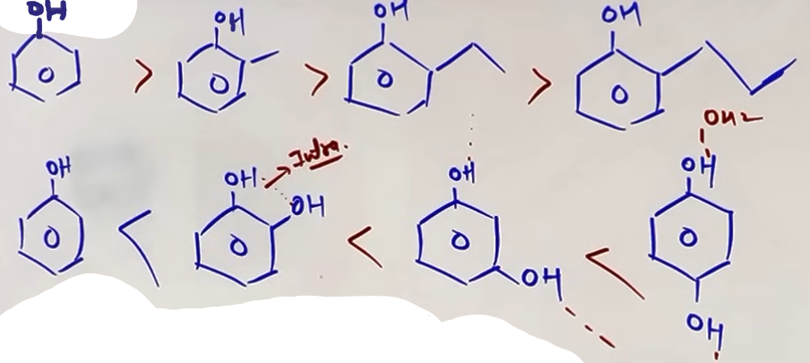
BOILING POINT (BP)
- Intermolecular Forces: Boiling point is directly proportional to the strength of the forces holding molecules together in the liquid phase.
- H-Bonding in Alcohols: Alcohols have significantly higher boiling points than alkanes, ethers, or haloalkanes of comparable molecular mass. This is due to the presence of strong intermolecular hydrogen bonding between alcohol molecules.
- Dipole-Dipole in Ethers: Ethers lack an O-H bond, so they cannot form H-bonds with themselves. They are held together by weaker dipole-dipole interactions, leading to lower boiling points than alcohols.
- Effect of Molecular Mass: Within the same series (e.g., all primary alcohols), the boiling point increases as the number of carbon atoms increases. This is because larger molecules have greater Van der Waals forces (specifically London dispersion forces).
- Effect of Branching: For isomeric alcohols (those with the same molecular formula), the boiling point decreases as branching increases.
- Reasoning for Branching: Increased branching makes the molecule more spherical. A sphere has the minimum surface area for a given volume, which reduces the Van der Waals attractive forces.
# pehle molecular mass hi dekhenge agar kinhi do m molecular mass same h toh branching dekhenge.
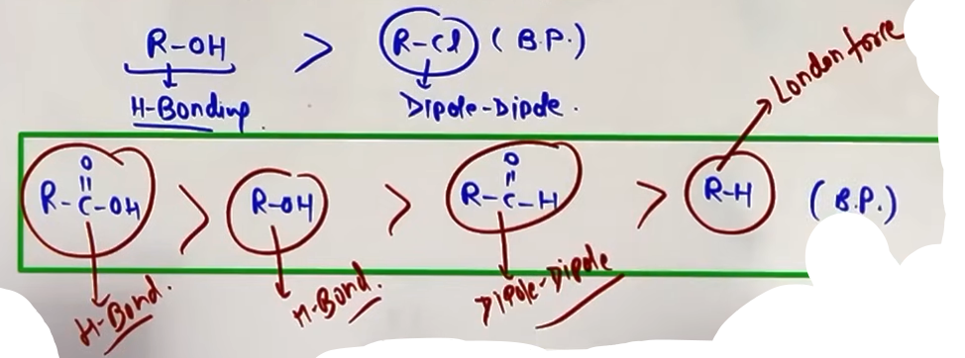
FORMULA SHEET AND DATA
SOLUBILITY TRENDS:
- Solubility ∝ 1 / Size of Alkyl group.
- Solubility of isomeric phenols: Quinol (para) > Resorcinol (meta) > Catechol (ortho).
- Reason: Ortho-isomers can undergo intramolecular H-bonding (bonding within the same molecule), which reduces their ability to bond with water.

BOILING POINT TRENDS:
- BP ∝ Molecular Weight.
- BP ∝ 1 / Branching.
- BP Order: Carboxylic Acids > Alcohols > Aldehydes/Ketones > Ethers > Haloalkanes > Hydrocarbons.
- Carboxylic acids have higher BP than alcohols because they form stable dimers via two H-bonds per pair of molecules.

PROBLEM-SOLVING FRAMEWORK
Question Type | Identification Clues | Approach / Strategy
Compare BP | Isomers (Same mass) | Check Branching. More branching = Lower BP.
Compare BP | Same functional group | Check Carbon count (Mass). Higher C = Higher BP.
Compare BP | Different groups | Use order: Acid > Alcohol > Ether > Alkane.
Compare Solubility | Increasing chain length | More carbons = Less soluble.
Compare Solubility | Ortho vs Para Phenols | Ortho is less soluble (Intramolecular H-bond).
EXAMPLES AND APPLICATIONS

EXAMPLE 1: BP OF ISOMERIC BUTANOLS
- n-Butanol (Straight chain): Highest BP due to maximum surface area.
- Isobutanol (One branch): Intermediate BP.
- t-Butanol (Highly branched): Lowest BP because it is the most spherical.

EXAMPLE 2: BP COMPARISON OF DIFFERENT GROUPS (Mass approx 46)
- Ethanol (CH3CH2OH): BP = 351 K (Strong H-bonds).
- Methoxymethane (CH3OCH3): BP = 248 K (Weak dipole-dipole).
- Propane (CH3CH2CH3): BP = 231 K (Weakest London forces).

COMMON MISTAKES AND TRAPS
Mistake | Why Students Make It | Correct Approach / Thinking
Ethers are insoluble | They lack OH groups. | Ethers ARE soluble via H-bonding WITH water.
BP proportional to C | Forgetting functional group. | Only compare C-count if the group is the same.
Ignoring Branching | Focusing only on mass. | For isomers, surface area (branching) is key.
Thinking O causes BP | Confusing dipole with H-bond | Only O-H bonds allow strong self-H-bonding.

HIGH-YIELD REVISION SHEET
MUST REMEMBER:
- BP: Acid > Alcohol > Ether > Alkane.
- Branching: More branches = Lower BP.
- Chain length: Longer chain = Lower Solubility.
- Intramolecular H-bond: Decreases solubility in water (common in ortho-isomers).

LAST-MINUTE REVISION POINTS:
- n-Pentanol has a higher BP than 2,2-dimethylpropan-1-ol.
- Phenol has a higher BP than toluene.
- Solubility drops off sharply after 4-5 carbons in a straight chain alcohol.
- The bond angle in ethers is greater than 109.5 degrees due to bulky R-group repulsion, whereas it is less in alcohols due to lone pair repulsion.
--------------------------------------------------------------------------------

CHEMICAL PROPERTIES OF ALCOHOLS: {VERSATILITY}

Alcohols are considered versatile compounds because they can react as both nucleophiles and electrophiles.

AS NUCLEOPHILES (O-H BOND BREAKS)
When an alcohol acts as a nucleophile, the oxygen atom uses its lone pair to attack an electrophilic center (such as a carbocation).
In this process, the oxygen-hydrogen (O-H) bond is broken to release a proton (H+) and stabilize the oxygen.
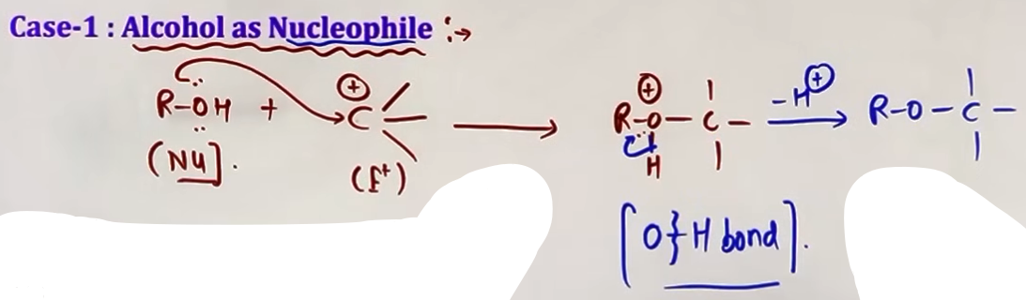
AS ELECTROPHILES (C-O BOND BREAKS)
An alcohol cannot act as an electrophile directly. It must first be protonated (usually by an acid catalyst) to form a protonated alcohol (oxonium ion).
This makes the carbon-oxygen bond highly polar. A nucleophile then attacks the carbon atom, causing the C-O bond to break and releasing water (H2O) as a leaving group.
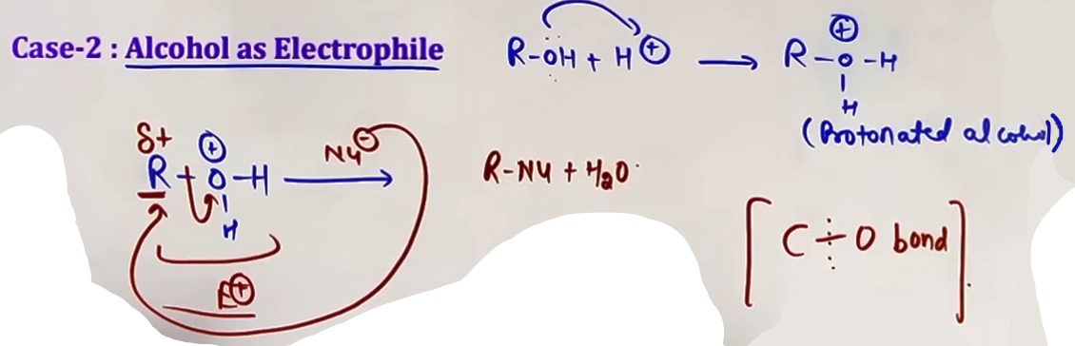
INTUITION AND CONCEPTUAL UNDERSTANDING
Think of the alcohol oxygen as having a "split personality." When it wants to share its electrons, it kicks off its own hydrogen (O-H cleavage). When it is forced to take on an extra proton, it becomes so uncomfortable that it grabs the electrons from the carbon and leaves entirely as water (C-O cleavage).

i) REACTIONS INVOLVING CLEAVAGE OF O-H BOND

CORE THEORY: ACIDITY OF ALCOHOLS
Alcohols exhibit acidic character due to the polar nature of the O-H bond.
#releasing H+

REACTION WITH METALS
Alcohols react with active metals like Sodium (Na), Potassium (K), and Aluminium (Al) to form alkoxides and release Hydrogen gas (H2).
Example: 2 R-OH + 2 Na -> 2 R-ONa + H2.
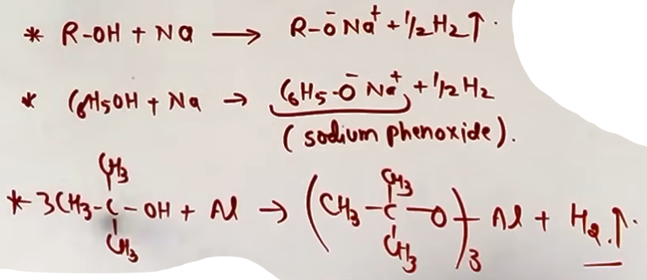
ACIDIC STRENGTH COMPARISON
The acidic strength of alcohols depends on the stability of the conjugate base (alkoxide ion).
Order of Acidity: Water > 1 degree > 2 degree > 3 degree.
Reasoning: Alkyl groups are electron-donating (+I effect). In 3-degree alcohols, three alkyl groups increase the negative charge density on the oxygen, making the alkoxide ion less stable and the alcohol less acidic.
EXCEPTION: Methanol (CH3OH) is slightly more acidic than water.
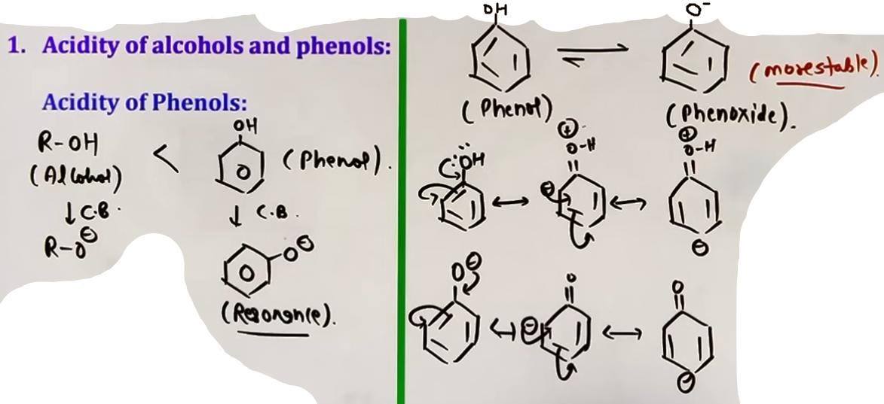
# phenol is more acidic than alcohol
# phenoxide is more stable than phenol because in the resonating structures of phenol there is +ve charge on oxygen but in resonating structures of phenoxide there is no +ve charge on the oxygen.
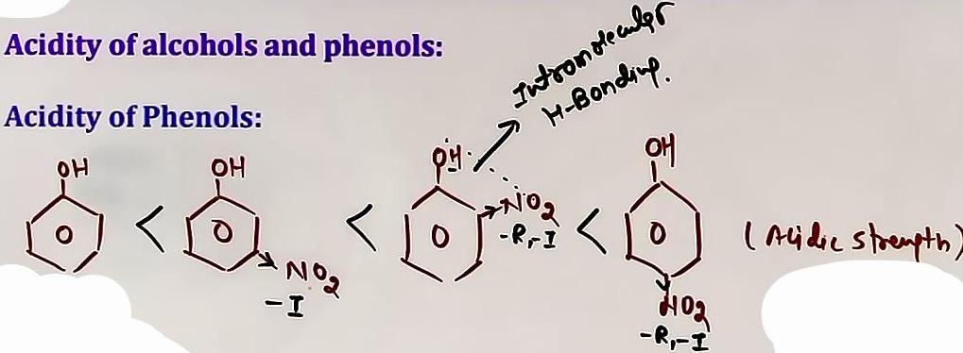
ESTERIFICATION {Imp}
Alcohols react with carboxylic acids, acid chlorides, and acid anhydrides to form esters.
Mechanism: This is a reversible reaction often catalyzed by an acid.
Key Insight: In the reaction between an acid and an alcohol, the O-H bond of the alcohol breaks (releasing H) and the C-OH bond of the carboxylic acid breaks (releasing OH) to form water.
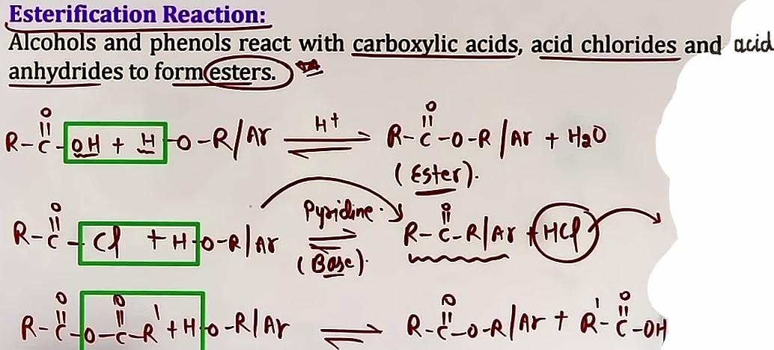
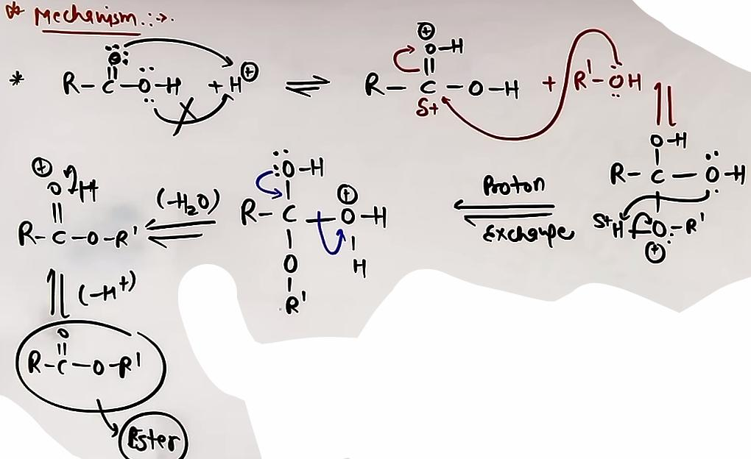
# sabse pehle wale m ‘=O’ se electron lega ‘-O’ se nahi kyunki ‘-O’ ke e- bagal wale pi bond se resonance m h, ’=O’ iske lone pair faltu baithe h.
# no carbocation formed
# reactivity of alcohol in esterification 1 degree > 2 degree > 3 degree due to stefic hinderance

SYNTHESIS OF ASPIRIN
Aspirin (Acetylsalicylic acid) is synthesized by the acetylation of Salicylic acid using Acetic Anhydride.

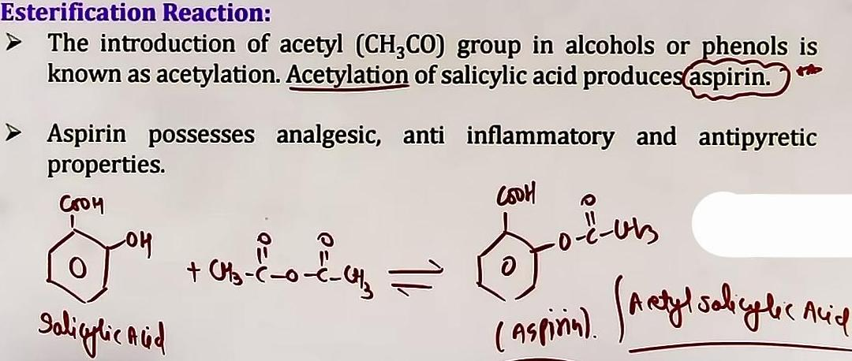

ii) C-O BOND CLEAVAGE REACTIONS

# isme 4 rxn h jisme se 3 pehle ho chuki h aur dehydration of alcohol chauthi h.
Alcohols react with various reagents to replace the -OH group with a halogen. These reactions involve the cleavage of the C-O bond.
1. Reaction with HX (Lucas Reagent): R-OH + HCl (ZnCl2) -> R-Cl + H2O.
2. Reaction with PX3/PCl5: Yields alkyl chlorides. PCl3 requires 3 moles of alcohol.
3. Reaction with SOCl2 (Thionyl Chloride): R-OH + SOCl2 -> R-Cl + SO2 + HCl. This is the preferred method because the byproducts (SO2 and HCl) are gases, leaving behind pure alkyl halide.
# alcohol ka C-O bond torna aasan hota h phenol k comparison m kyunki phenol k C-O bond m partial double bond character hota h.
DEHYDRATION :- {Imp}
Alcohols undergo dehydration (removal of water) to form alkenes when treated with protic acids like concentrated H2SO4 or H3PO4. ♔ question aaya h ispe !!
MECHANISM (E1)
1. Protonation: Alcohol reacts with H+ to form a protonated alcohol.
2. Carbocation Formation: The C-O bond breaks, releasing water and forming a carbocation (Slowest/RDS step).
3. Deprotonation: A beta-hydrogen is removed to form the C=C double bond.
STABILITY AND REACTIVITY
The ease of dehydration follows the stability of the carbocation: 3ᵒ > 2ᵒ > 1ᵒ.
Note: Carbocation rearrangements (shifts) can occur during this process to form more stable intermediates.
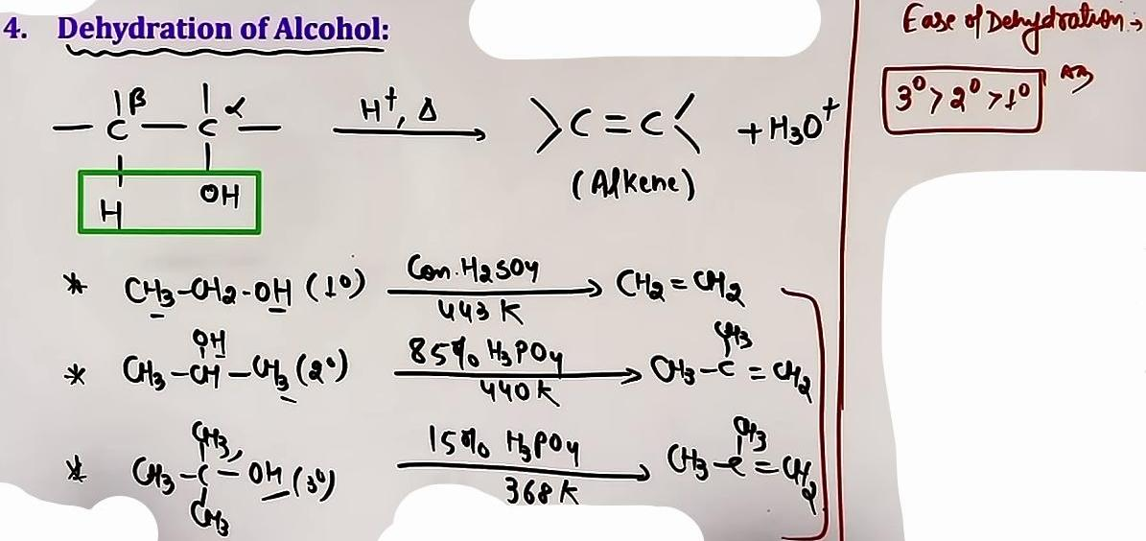
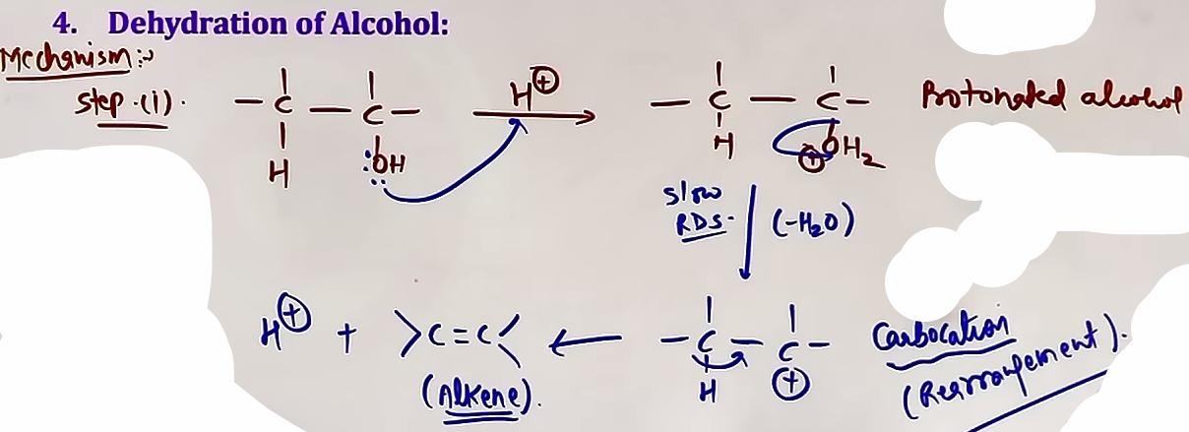
# Other dehydrating agents like Al2O3, P2O5 and POCl3 can be used to get alkene without rearrangement.

iii) OXIDATION REACTIONS

Oxidation of alcohols involves the removal of hydrogen from both the oxygen (O-H) and the carbon (C-H) to form a carbonyl (C=O) group.

OXIDATION BY ALCOHOL DEGREE
1. Primary (1 degree): Oxidized to Aldehydes (using mild agents) or Carboxylic Acids (using strong agents).
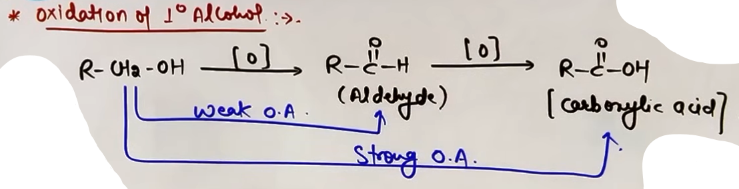
2. Secondary (2 degree): Oxidized to Ketones.
3. Tertiary (3 degree): Do not undergo oxidation under normal conditions.
- Catalytic Dehydrogenation: Passing alcohol vapors over Red Hot Copper (Cu) at 573 K.
# another way of oxidising.
- 1 degree -> Aldehyde.
- 2 degree -> Ketone.
- 3 degree -> Alkene (due to dehydration{elimination}, not oxidation).
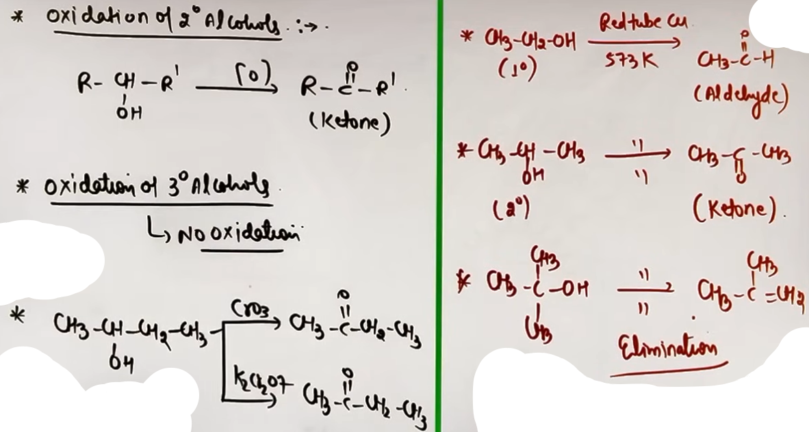
OXIDATION OF ALLYLIC AND BENZYLIC ALCOHOLS BY MnO2 (Mild Oxidising Agent)
- MnO2: Specifically used for the oxidation of Allylic and Benzylic alcohols to aldehydes or ketones.
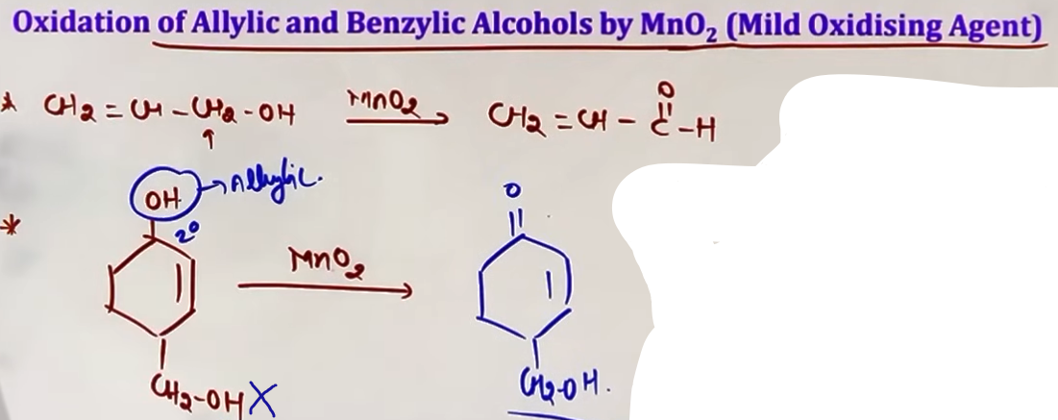sirf allylic aur benzylic ko karta h isliye neeche wale ko nahi kiya.
REAGENTS
- Mild Oxidizing Agents: PCC (Pyridinium Chlorochromate) and PDC are used to stop the oxidation of 1-degree alcohols at the aldehyde stage.
- Strong Oxidizing Agents: KMnO4 (acidic/basic) or Jones Reagent (CrO3 in H2SO4) oxidize 1-degree alcohols directly to Carboxylic Acids.
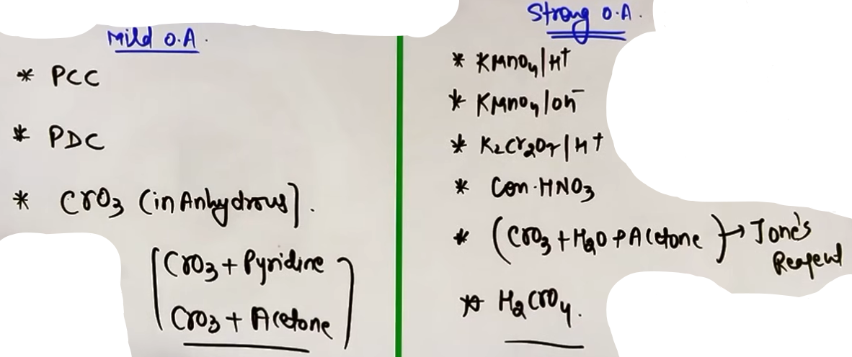
FORMULA SHEET
Starting Material | Reagent | Major Product
R-OH (1 deg) | PCC | R-CHO (Aldehyde)
R-OH (1 deg) | KMnO4 / H+ | R-COOH (Acid)
R-OH (2 deg) | PCC or KMnO4 | R-CO-R (Ketone)
R-OH (1 deg) | Cu / 573 K | R-CHO + H2
R-OH (3 deg) | Cu / 573 K | Alkene (Dehydration)
Alcohol + Acid | H+ (heat) | Ester + H2O
Alcohol | Conc. H2SO4 (heat) | Alkene

PROBLEM-SOLVING FRAMEWORK
Question Type | Identification Clues | Approach / Strategy
Compare Acidity | 1, 2, 3 deg alcohols | 1 deg is most acidic due to less +I.
Major Dehydration | Alcohol + H2SO4 | Form most stable cation; check for shifts.
Esterification H/O | Labelled O (O-18) | Alcohol provides H; Acid provides OH.
Selective Oxid. | PCC vs KMnO4 | PCC stops at Aldehyde; KMnO4 goes to Acid.

COMMON MISTAKES AND TRAPS
Mistake | Why Students Make It | Correct Approach / Thinking
3-deg alc. oxidation | Assuming all oxidize | 3-deg alcohols do not oxidize; they dehydrate.
Acid provides H+ | Thinking acids always give H+ | In esterification, Acid gives OH- and Alcohol gives H+.
Water vs Alcohol | Generalizing acidity | Water is more acidic than most alcohols except Methanol.
Ignoring Shifts | In dehydration RDS | Always check if a carbocation can shift (methyl/hydride).

HIGH-YIELD REVISION SHEET
MUST REMEMBER
- Versatility: Nucleophile = O-H breaks; Electrophile = C-O breaks.
- Acidity Order: Methanol > Water > 1 deg > 2 deg > 3 deg.
- Dehydration: E1 mechanism via carbocation. Watch for rearrangements.
- PCC: The "magic reagent" to stop 1-degree alcohol oxidation at the aldehyde stage.
- Aspirin: Formed from Salicylic acid and Acetic Anhydride.

LAST-MINUTE REVISION POINTS
- Cu at 573 K with 3-degree alcohol gives an ALKENE, not a carbonyl.
- MnO2 is the specific "sniper" for Allylic and Benzylic alcohols.
- Esterification is reversible; use H2SO4 to remove water and shift equilibrium forward.
- Lucas Test (HCl/ZnCl2): 3 deg (immediate), 2 deg (5-10 mins), 1 deg (no reaction at room temp).

--------------------------------------------------------------------------------

OTHER REACTIONS

1. PINACOL-PINACOLONE REARRANGEMENT

This is an acid-catalyzed rearrangement specific to vicinal diols (glycols)(pinacol), where the diol is converted into a ketone (pinacolone) with the loss of a water molecule.

CONDITIONS AND MECHANISM
1. Protonation: One of the hydroxyl (OH) groups reacts with H plus to form a protonated alcohol (oxonium ion).
2. Carbocation Formation: A water molecule (H2O) leaves, creating a carbocation. This is the Rate Determining Step (RDS). H2O waha se hatega jahan most stable carbocation banega migratory tendency uske baad dekhenge.
3. Migration (The Rearrangement): An alkyl or aryl group from the adjacent carbon migrates to the carbocationic center to form a more stable, resonance-stabilized oxonium ion.
4. Deprotonation: Loss of H plus from the oxygen yields the final ketone (pinacolone).
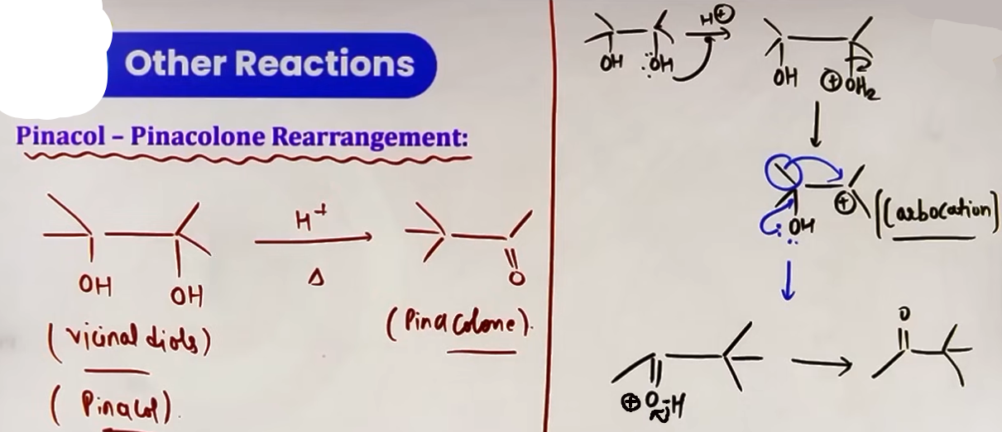
MIGRATORY APTITUDE
When different groups are present, the group with the highest migratory tendency moves:
Hydrogen (H) > Phenyl (Ph) > Alkyl groups.
For Alkyl groups: 3ᵒ > 2ᵒ > 1ᵒ.
For substituted Phenyl rings: Presence of electron-donating groups (EDG) increases the migratory aptitude (e.g., p-methoxyphenyl greater than phenyl).

INTUITION AND CONCEPTUAL UNDERSTANDING
Think of this as a molecule "upgrading" its stability. The carbocation formed initially is stable, but the molecule realizes it can be even more stable if the positive charge is shared with the oxygen's lone pair (resonance). To achieve this, it moves a neighboring group out of the way.

2. PERIODIC ACID OXIDATION (HIO4)

Periodic acid (HIO4) specifically cleaves the Carbon-Carbon (C-C) bond in vicinal diols (compounds with OH groups on adjacent carbons).

PROBLEM-SOLVING TECHNIQUE (TRICK)
1. Identify the C-C bond between the two carbons holding the OH groups.
2. Break that C-C bond completely.
3. Convert each C-OH group into a C=O group.
4. If a carbon's bond was broken twice (as in a triol), add another OH group to that carbon, making it a carboxylic acid (H-COOH) after water loss.
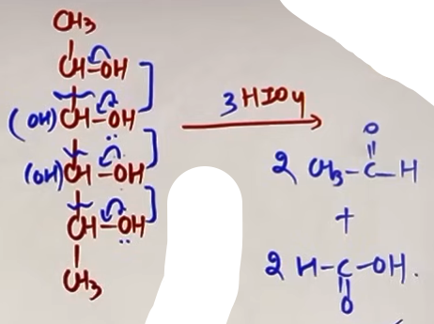
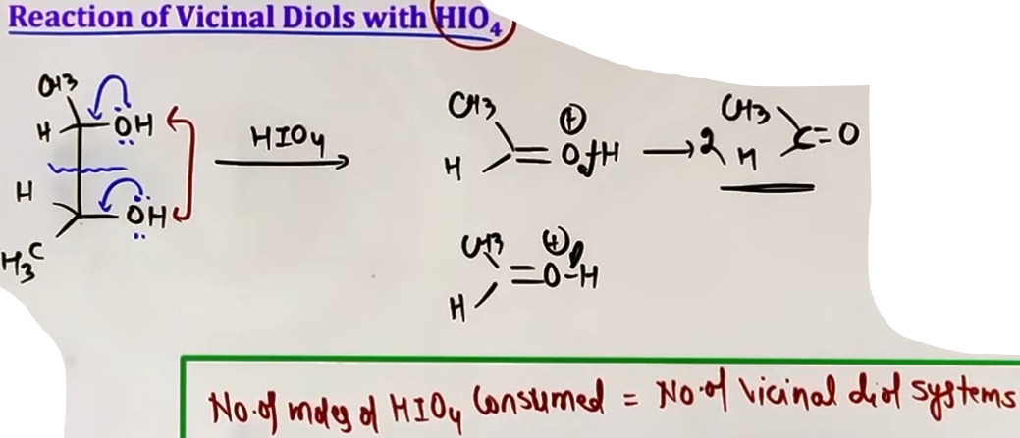isme sirf ek mole consume hoga kyunki sirf ek vicinal diol systems h

#isme teen mole HIO4 consume hue.

HIGH-YIELD OBSERVATION: MOLE CALCULATION
Number of moles of HIO4 consumed = Number of vicinal diol C-C bonds present in the system.

3. HALOFORM (IODOFORM) REACTION {imp}
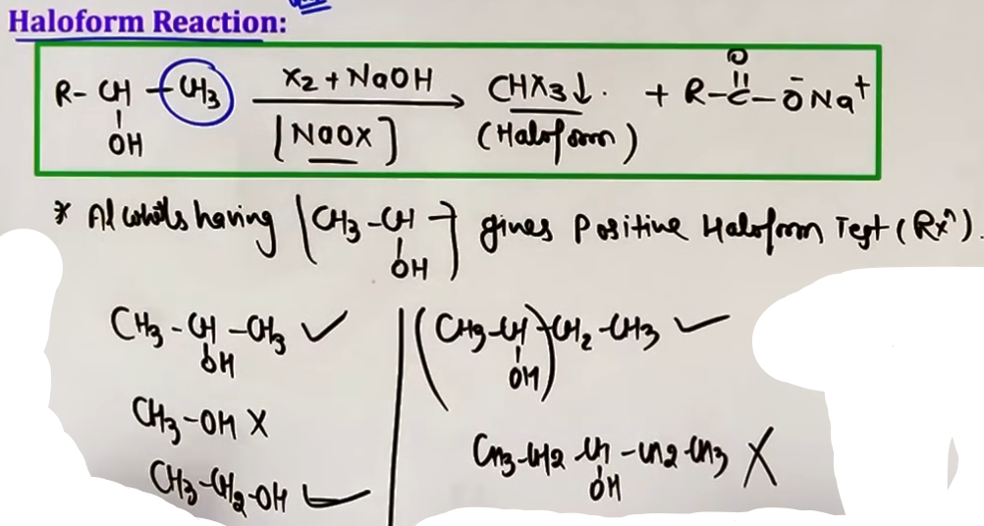
This is a diagnostic test used to identify alcohols containing the CH3-CH(OH)- group.

REAGENTS AND OBSERVATION
Reagents: Iodine (I2) and Sodium Hydroxide (NaOH), which generate Sodium Hypoiodite (NaOI) in situ.
Positive Result: Formation of a yellow crystalline precipitate of Iodoform (CHI3).

CHEMICAL REASONING
1. The NaOI acts as a mild oxidizing agent, first converting the alcohol into a methyl ketone (CH3-CO-R).
2. The methyl ketone then undergoes halogenation and cleavage by the base to produce the haloform and a carboxylate salt.
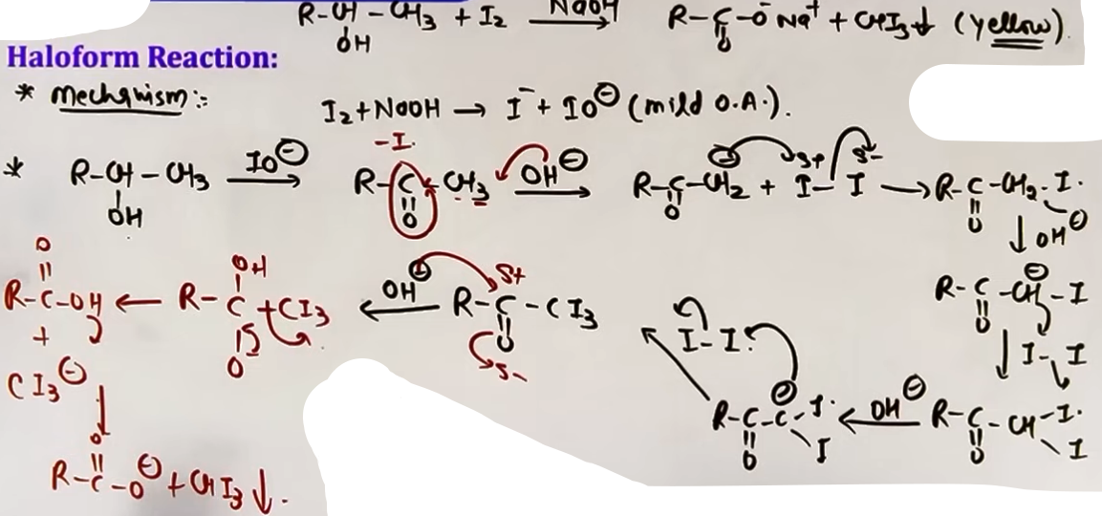mechanism ki jagah seedhe kar sakte h.

IDENTIFICATION TESTS FOR ALCOHOLS

A. LUCAS TEST
Used to distinguish between 1ᵒ, 2ᵒ, and 3ᵒ alcohols based on their reactivity with the Lucas Reagent.
Reagent: Concentrated HCl and Anhydrous ZnCl2.
Mechanism: Proceeds via carbocation formation.
Results:
- 3 degree Alcohol: Immediate white turbidity (cloudiness).
- 2 degree Alcohol: White turbidity appears in 5 to 10 minutes.
- 1 degree Alcohol: No turbidity at room temperature; may appear on heating.
Special Case: Benzylic and allylic alcohols give immediate turbidity due to high carbocation stability.

B. VICTOR MEYER TEST
A series of reactions used to distinguish alcohol degrees by the final color of the solution.
Sequence: Alcohol + P/I2 → Alkyl Iodide + AgNO2 → Nitroalkane + HNO2 → Solution + NaOH.
Results (RBW Rule):
- 1 degree Alcohol: Red color (Nitrolic acid salt).
- 2 degree Alcohol: Blue color (Pseudo-nitrole).
- 3 degree Alcohol: White / Colorless (No reaction with HNO2).

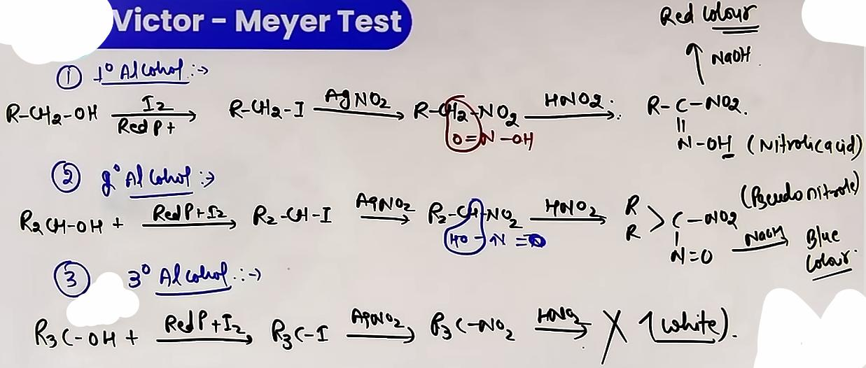
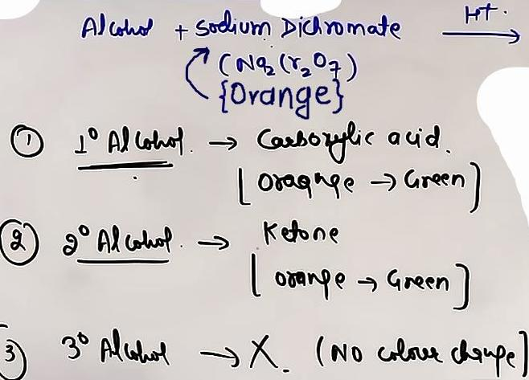

C. DICHROMATE TEST
Based on the oxidation of alcohols.
Reagent: Sodium Dichromate (Na2Cr2O7) in dilute H2SO4.
Observation: The orange color of Cr+6 (dichromate) changes to green Cr+3.
Results:
- 1 degree and 2 degree Alcohols: Orange to Green.
- 3 degree Alcohol: No color change (as they are resistant to oxidation).

FORMULA SHEET
Test / Reaction | Reagent | Key Product / Observation
Pinacol | H plus / Heat | Pinacolone (Ketone)
HIO4 Oxidation | HIO4 | Cleaved Carbonyls
Iodoform Test | I2 + NaOH | Yellow PPT (CHI3)
Lucas Test | Conc. HCl + Anhyd. ZnCl2 | Turbidity (Cloudiness)
Victor Meyer | P/I2, AgNO2, HNO2, NaOH | Red(1), Blue(2), White(3)
Dichromate | Na2Cr2O7 + H2SO4 | Orange to Green (1 and 2)

PROBLEM-SOLVING FRAMEWORK
Question Type | Identification Clues | Approach / Strategy
Predict Pinacol | Vicinal diol + Acid | 1. Protonate OH for stable cation. 2. Migrate best group.
Moles of HIO4 | Polyhydroxy compound | Count the number of C-C bonds between adjacent OH groups.
Distinguish | 1 vs 2 vs 3 degree | Use Lucas (Time) or Victor Meyer (Color).
Iodoform Check | Alcohol structure | Look for the CH3-CH(OH)- unit.

CONCEPT CONNECTIONS
- GOC: Carbocation stability is the driving force for both the Lucas test and the Pinacol rearrangement.
- CARBOXYLIC ACIDS: The haloform reaction links alcohols to the salts of carboxylic acids with one less carbon atom.
- INORGANIC CHEMISTRY: The color changes in the dichromate test (Orange to Green) and the formation of the hypoiodite ion are standard redox concepts.

HIGH-YIELD REVISION SHEET
MUST REMEMBER:
- Pinacol RDS: Formation of the most stable carbocation.
- Victor Meyer Color: Red-1, Blue-2, White-3 (Remember as "RBW").
- HIO4: Moles = Number of C-C bonds to break.
- Lucas: 3 degree is instantaneous; 1 degree is "infinite" time at room temp.
- Iodoform: Specifically needs the CH3-CH(OH)- group.
LAST-MINUTE REVISION POINTS:
- Phenyl groups with EDG (like -OCH3) migrate faster in Pinacol rearrangement.
- HIO4 can also cleave alpha-hydroxy carbonyls and alpha-diketones.
- Sodium salt of salicylic acid is the first step in the synthesis of Aspirin (not a test, but a related named reaction).
- 3 degree alcohols do not change the color of orange dichromate solution.
--------------------------------------------------------------------------------
CHEMICAL PROPERTIES OF PHENOLS

DISTINGUISHING TESTS (PHENOL VS ALCOHOLS)
Phenols can be identified using reagents that do not produce the same results with aliphatic alcohols.

Rxn With NaOH:
phenol + NaOH → C6H5-O⁻Na⁺{Sodium phenoxide} + H2O
alcohol + NaOH → No rxn # alcohol is not acidic enough

Neutral Ferric Chloride (FeCl3) Test:
Phenols react with neutral FeCl3 solution to form a violet-colored complex. Alcohols do not show this color change, making this a specific test for the phenolic OH group. ♔ Ispe question aaya h !!
Phenol + FeCl3 → (C6H5-O-)3Fe {Violet} + 3HCl
alcohol + FeCl3 → No rxn
Bromine Water Test: ♔ Ispe question aaya h product p!!
When phenol is treated with Bromine water (Br2/H2O), the reddish-brown color of bromine is decolorized, and a white precipitate of 2,4,6-tribromophenol is formed. Alcohols generally do not react with bromine water to form a precipitate.

DISTINGUISHING TESTS (PHENOL VS CARBOXYLIC ACIDS)

FeCl3 test
phenol + FeCl3 --> Violet colour {as before}
R-COOH + FeCl3 --> (RCOO)3Fe{Buff colour} + HCL

NaHCO3 Test
R-COOH + NaHCO3 --> RCOO⁻Na⁺ + H2O + CO2↑{Turns lime water milky}
phenol + NaHCO3 --> No rxn
# but picric acid acid or 2,4-Dinitrophenol react with NaHCO3 to liberate CO2

ELECTROPHILIC AROMATIC SUBSTITUTION (EAS)
The -OH group is a strong activating group and is ortho-para directing.

Nitration:
1. Dilute HNO3 (Room Temp): Yields a mixture of ortho and para nitrophenols.
#o-nitrophenol m intramolecular H-bonding hogi aur p-nitrophenol n intermolecular isliye p-nitrophenol ka boiling point o-nitrophenol se jyada hota h isliye inhe steam distillation se separate kiya ja sakta h.

2. Concentrated HNO3: Yields 2,4,6-trinitrophenol (Picric Acid). The yield is often low due to ring oxidation by the concentrated acid.

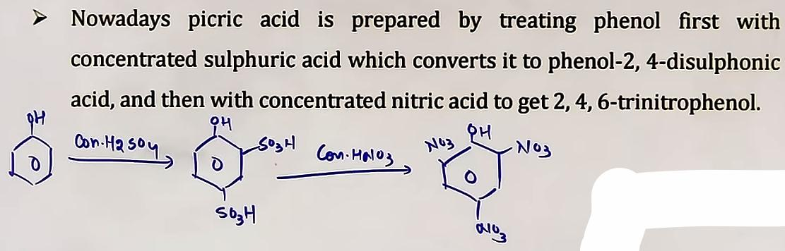
# picric acid k yield kafi kam hote h kyunki NO2 deactivation group h (e- kheech leta h) toh ek NO2 k lagta ki compound ki reactivity EAS k liye kam ho jayegi aur phir dusre NO2 k lagne se toh aur kam.

Halogenation:
1. Low Polarity Solvents (CS2, CCl4 at 273K): Yields monobrominated products (ortho or para).
C6H5-OH +Br2 {CHCl3} -> o-bromophenol + p-bromophenol
2. High Polarity Solvents:
C6H5-OH +Br2 {H2O} -> 2,4,6-tribromophenol
Note: No Lewis acid (like FeBr3) is required for phenol halogenation because the -OH group is so activating that it can polarize the Br2 molecule itself.

Sulphonation (Temperature Dependent):
At 25 degrees C (Low Temp): Ortho-phenolsulphonic acid is the major product (Kinetic Control/stable Product).
At 100 degrees C (High Temp): Para-phenolsulphonic acid is the major product (Thermodynamic Control/stable Product).

NAMED REACTIONS

Friedel Craft
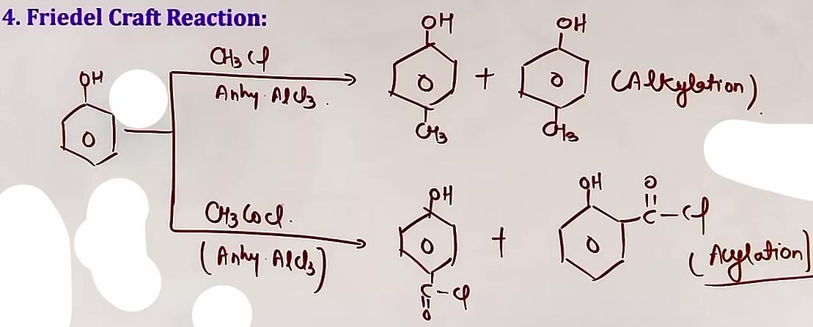
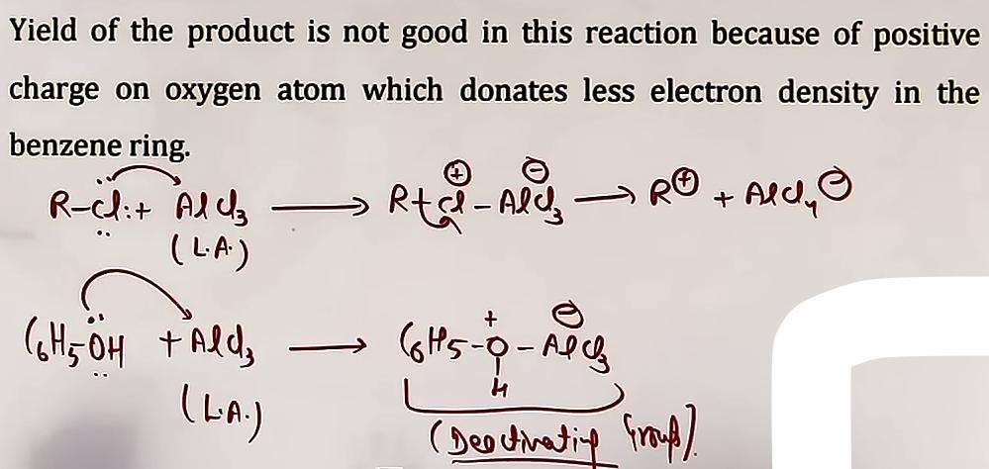
Kolbe's Reaction: {Imp}
Phenol reacts with NaOH to form sodium phenoxide, which then reacts with CO2 (electrophile) followed by acidification to produce Salicylic acid (2-hydroxybenzoic acid). The major product is the ortho isomer due to intramolecular H-bonding stabilization.
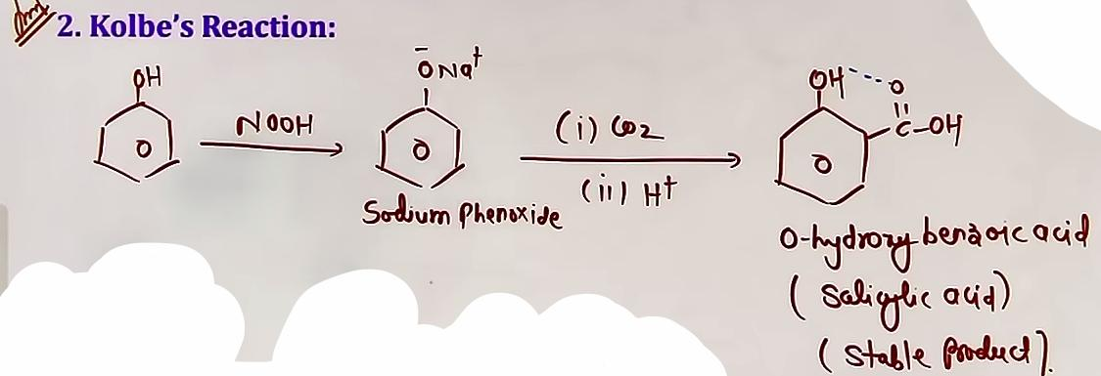para product bhi banega but minor quantity m
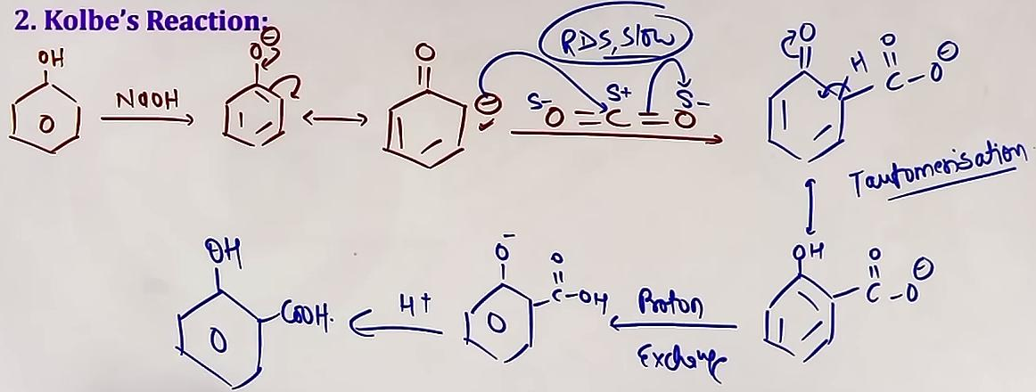# Mechanism, pehle phenoxide ka resonating structure banaya phir CO2 se rxn karae seedhe is liye nahi karaha kyunki Oxygen, Carbon se jyada E.N. h vo e- dena nahi chahta.
Reimer-Tiemann Reaction: {Imp}
Phenol reacts with chloroform (CHCl3) and aqueous NaOH to form Salicylaldehyde (2-hydroxybenzaldehyde). The active intermediate is the neutral electrophile Dichlorocarbene (:CCl2). ♔ qs aaya h iske intermediate par “phenoxide-CHCl2”
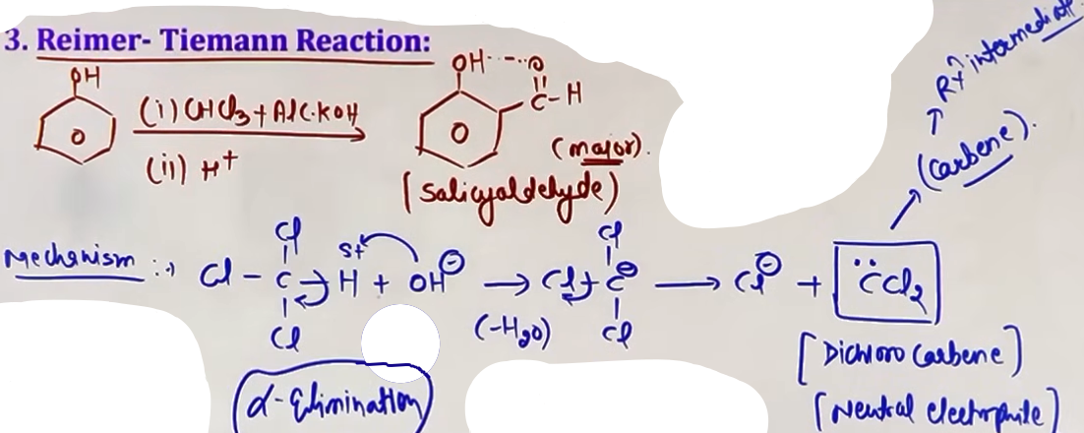
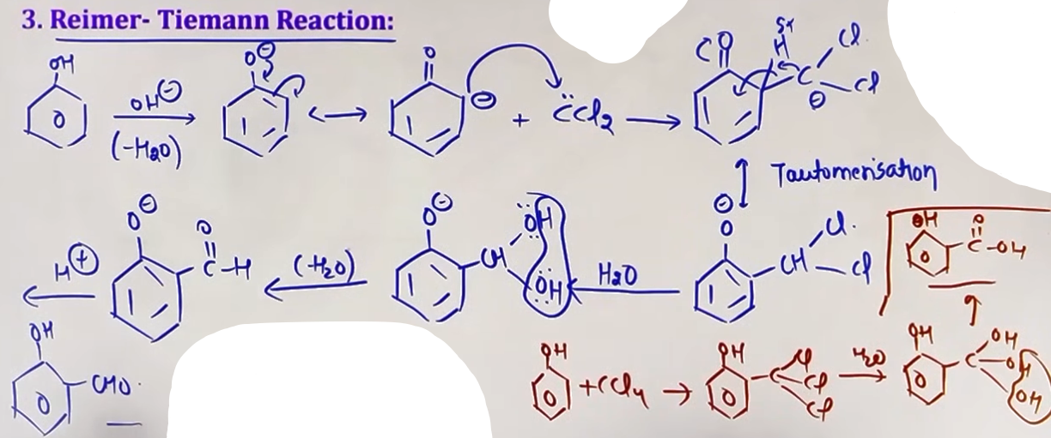

Carbene
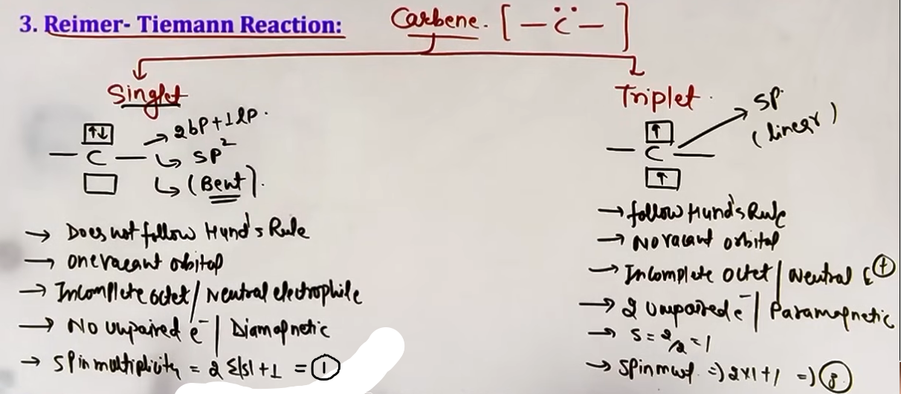
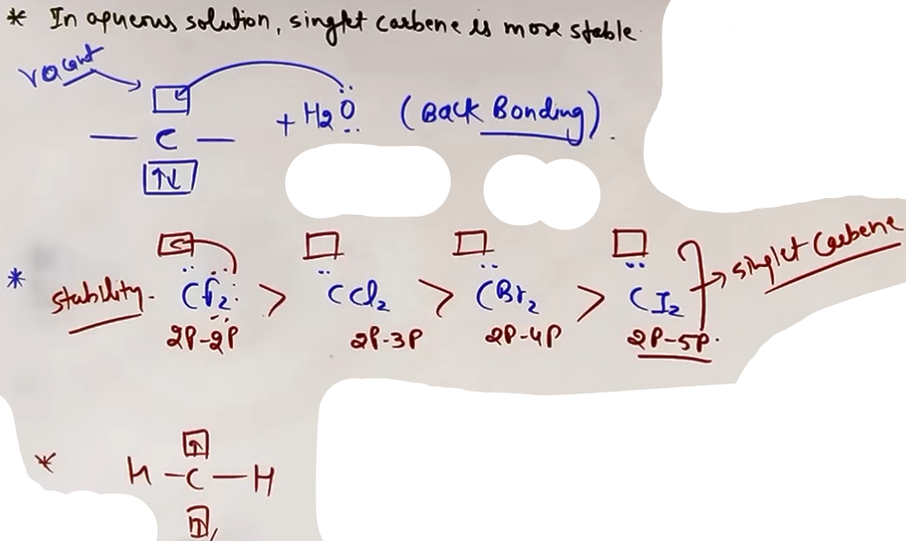
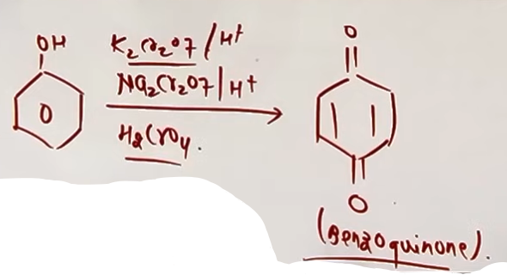
# jab C se aisa atom juda h jispe lone pair h toh vo singlet form m rahega kyunki tab uske pass ek vacant orbital hoga aur back bonding se compound stable banega, aur water m bhi singlet wala hi jyada stable hota h for the same reasons.

REDUCTION AND OXIDATION

Reduction: Heating phenol with Zinc dust removes the oxygen atom, producing Benzene.
phenol + Zn(dust) -> benzene + ZnO
Oxidation: Phenol is oxidized by chromic acid (Na2Cr2O7/H2SO4) to form Benzoquinone (a conjugated diketone).

♔ reduction (Zn) wali eqn p question aaya h !!
--------------------------------------------------------------------------------

INTUITION AND CONCEPTUAL UNDERSTANDING
MENTAL MODEL FOR ACIDITY
Think of the oxygen as having a "burden" (the negative charge). In alcohols, alkyl groups "push" more electrons toward it (+I), increasing the burden. In phenols, the benzene ring "pulls" the charge away through resonance, spreading the burden across the entire ring. This makes the phenoxide ion more stable and the phenol more acidic.

STEAM VOLATILITY VISUALIZATION
Ortho-nitrophenol is like a person holding their own hands (intramolecular H-bonding). They are compact and don't interact much with neighbors, so they turn into steam easily. Para-nitrophenol is like a person holding hands with others in a chain (intermolecular H-bonding). This creates a heavy network that is harder to evaporate.

REIMER-TIEMANN INTERMEDIATE
Think of Dichlorocarbene as a "hungry" neutral molecule. Even though it is neutral, it has an empty pocket (vacant orbital) and wants electrons. It finds the electron-rich benzene ring and attacks it to get those electrons.

FORMULA SHEET
NAME | FORMULA | REAGENTS
Phenoxide Ion | C6H5O⁻ | Phenol + NaOH
Picric Acid | 2,4,6-Trinitrophenol | Phenol + Conc. HNO3
Salicylic Acid | 2-Hydroxybenzoic Acid | Phenol + NaOH + CO2 + H+
Salicylaldehyde | 2-Hydroxybenzaldehyde | Phenol + CHCl3 + NaOH + H+
Benzoquinone | C6H4O2 | Phenol + Na2Cr2O7 + H2SO4
Benzene | C6H6 | Phenol + Zinc Dust (heat)

PROBLEM-SOLVING FRAMEWORK
QUESTION TYPE | IDENTIFICATION CLUES | APPROACH / STRATEGY
Distinguish Alcohol/Phenol | FeCl3 or Br2 water | Phenol = Violet with FeCl3; White ppt with Br2/H2O.
Compare Acidity | EWG/EDG substituents | EWG increases acidity; Para NO2 > Ortho NO2.
Separation of Isomers | Nitrophenols | Use Steam Distillation (Ortho is more volatile).
Named Reaction ID | CHCl3+NaOH or CO2+NaOH | CHCl3 = Reimer-Tiemann (Aldehyde); CO2 = Kolbe (Acid).

[ REACTION WITH SODIUM BICARBONATE (NaHCO3)
Concept: Acid strength.
Key Idea: Simple phenol does not react with NaHCO3 to release CO2 because it is a weak acid. However, Picric acid (2,4,6-trinitrophenol) is strong enough to give a positive bicarbonate test. ]

JEE ADVANCED INSIGHTS

SINGLET VS TRIPLET CARBENE:
In the Reimer-Tiemann reaction, the :CCl2 intermediate is a singlet carbene. In aqueous solution, singlet carbene is more stable because of back-bonding from chlorine lone pairs into the vacant p-orbital of carbon.

FRIEDEL-CRAFTS LIMITATION:
Phenols give poor yields in Friedel-Crafts alkylation/acylation because the Lewis acid (AlCl3) coordinates with the oxygen lone pair, turning the activating OH group into a deactivating positive group.

REIMER-TIEMANN WITH CCL4:
If CCl4 is used instead of CHCl3 in the Reimer-Tiemann reaction, Salicylic acid is formed instead of Salicylaldehyde because three chlorines are replaced by OH groups, which then eliminate water to form a carboxyl group.

COMMON MISTAKES AND TRAPS
MISTAKE | WHY STUDENTS MAKE IT | CORRECT APPROACH / THINKING
Acidity: Ortho > Para | Thinking inductive effect | Para is more acidic because Ortho H is trapped in H-bonding.
Using Lewis acid for Br2 | Generalizing from Benzene | Phenol is so activated it doesn't need FeBr3 for Br2 water.
Phenol + NaHCO3 = CO2 | Assuming all acids react | Simple phenol is too weak; NaHCO3 test is negative for it.
Reimer-Tiemann = Acid | Confusing with Kolbe | CHCl3 leads to an aldehyde. CO2 leads to an acid.

HIGH-YIELD REVISION SHEET
MUST REMEMBER:
- Acidity: p-Nitrophenol > o-Nitrophenol > Phenol > Alcohol (except Methanol).
- Reimer-Tiemann Intermediate: Dichlorocarbene (:CCl2).
- Distinguishing Test: Phenol + neutral FeCl3 -> Violet color.
- Picric Acid: 2,4,6-Trinitrophenol (Prepared with Conc. HNO3).
- Reduction: Phenol + Zn dust (heat) -> Benzene.

LAST-MINUTE REVISION POINTS:
- Ortho-nitrophenol is steam volatile due to intramolecular H-bonding.
- NO2 at meta position only increases acidity via -I effect, not -M.
- O-H bond breaks when phenol shows acidity or acts as a nucleophile.
- Phenol + Na2Cr2O7/H2SO4 -> Benzoquinone.
- Bromine water + Phenol -> White precipitate (Test for Phenol).

--------------------------------------------------------------------------------
Commercially important alcohols:

1. Methanol:
- Methanol, also known as ‘wood spirit’, was produced by destructive distillation of wood.
- Today, most of the methanol is produced by catalytic hydrogenation of carbon monoxide at high pressure and temperature and in the presence of ZnO-Cr2O3 catalyst.
- Methanol is a colourless liquid and boils at 337K.
- It is highly poisonous in nature. Ingestion of even small quantities of methanol can cause blindness and large quantities causes even death.
- Methanol is used as a solvent in paints, varnishes and chiefly for making formaldehyde.

2. Ethanol:
- Ethanol is obtained commercially be fermentation, the oldest method is from sugars.
- The sugar in molasses, sugarcane or fruits such as grapes is converted to glucose and fructose, in the presence of an enzyme, invertase.
- Glucose and fructose undergo fermentation in the presence of another enzyme, zymase, which is found in yeast.
- Fermentation takes place in anaerobic conditions i.e. in absence of air. Carbon dioxide is released during fermentation.
- If air gets into fermentation mixture, the oxygen of air oxidises ethanol to ethanoic acid which in turn destroys the taste of alcoholic drinks.
- Ethanol is a colourless liquid with boiling point 351K.
- It is used as a solvent in paint industry and in the preparation of a number of carbon compounds.
- The commercial alcohol is made unfit for drinking by mixing in it some copper sulphate (to give it a colour) and pyridine (a foul smelling liquid). It is known as denaturation of alcohol.

--------------------------------------------------------------------------------

ETHERS

Ethers are compounds with an R-O-R structure. They are classified as Symmetrical (Simple) if both R groups are the same, and Unsymmetrical (Mixed) if they differ.

BOND ANGLE INSIGHT
In ethers, the C-O-C bond angle is actually greater than the ideal tetrahedral angle of 109.5 degrees (around 111-117 degrees). This is because the bulky alkyl groups (R) repel each other, overcoming the lone pair-bond pair repulsion that usually shrinks bond angles in alcohols.

METHODS OF PREPARATION (MOP)

A. DEHYDRATION OF ALCOHOLS
This is a temperature-dependent reaction catalyzed by H2SO4.
1. Conditions:

- At 443 K: Intra-molecular dehydration occurs, yielding Alkenes.
- At 413 K: Inter-molecular dehydration occurs, yielding Ethers.
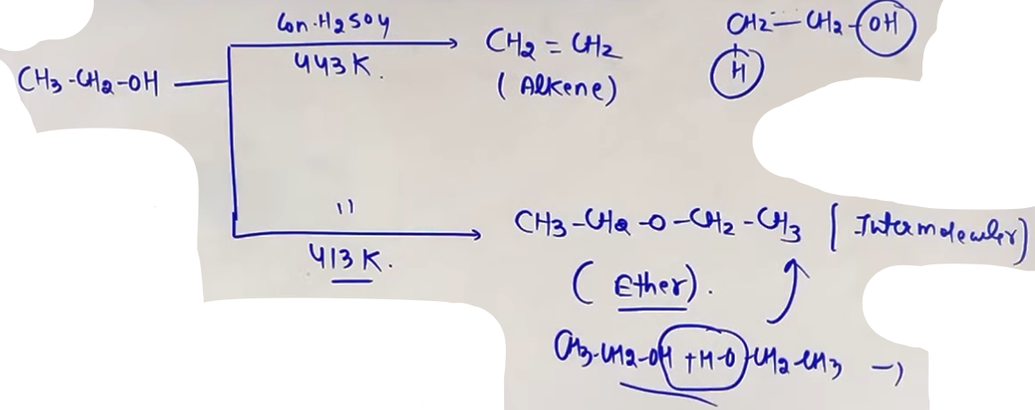
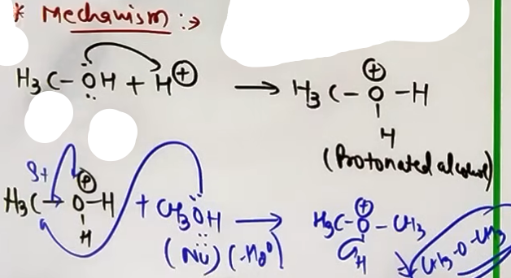

2. Limitations:

- This method is best suited for 1-degree alcohols and the preparation of Symmetrical Ethers.
- Attempting to make unsymmetrical ethers leads to a mixture of three different ethers, which are hard to separate.
R-OH + R'-OH -> R-O-R + R-O-R' + R'-O-R'
- With 2-degree or 3-degree alcohols, elimination dominates at these temperatures, yielding alkenes instead of ethers.

B. WILLIAMSON ETHER SYNTHESIS

This is a nucleophilic substitution (SN2) reaction between an alkyl halide (R-X) and a sodium alkoxide (R-ONa). ♔ question aaya h ispe
1. Core Reaction: R-X + R-ONa -> R-O-R + NaX. (Sn2)
2. The Critical Constraint:
- All ethers (sym., unsym., 1ᵒ,2ᵒ,3ᵒ) can be prepared.
- Better results are obtained when alkyl halide is 1ᵒ.
- If a 2-degree or 3-degree alkyl halide is used, the alkoxide acts as a base, causing elimination (E2) to become the major pathway, yielding Alkenes.
- The alkoxide ion is both a strong nucleophile and a strong base.
- You can use a 3-degree alkoxide with a 1-degree halide to successfully make a 3-degree ether.
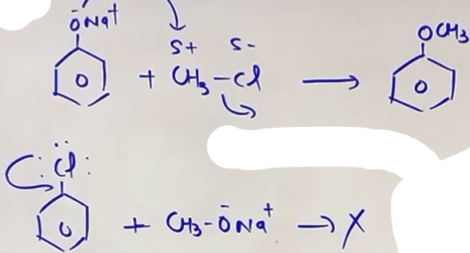

# dusre wale m rxn isliye nahi hui kyunki partial double bond character h bond is harder to break.

C. Alkoxymercuration-Demercuration rxn
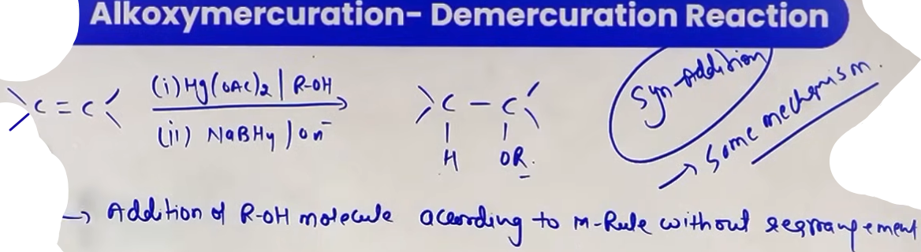
PHYSICAL PROPERTIES

Solubility
- solubility of ethers in water is comparable to that of alcohols as both are able to form hydrogen bond with water.
- solubility decreases with increase in molecular mass as the hydrophobic part is increasing.

Boiling Point
- The intermolecular force between ethers is dipole-dipole Vander wall's force, ethers can do H-bonding with the water but not with each others. Therefore, the boiling point of ethers is less than alcohols of comparable molecular mass, but greater than the boiling point of comparable alkanes (London force).

CHEMICAL PROPERTIES OF ETHERS
Ethers are the least reactive of the functional groups. The cleavage of C-O bond in ethers takes place under drastic conditions.

CLEAVAGE BY HX (HI OR HBR)
This is the most important chemical property of ethers. It involves breaking the C-O bond using a strong acid.
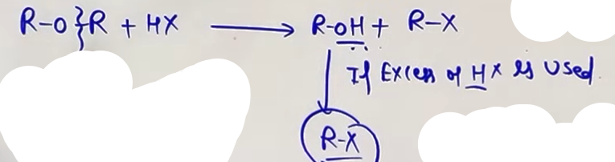
UNDERSTANDING SN1 VS SN2 PATHWAYS
The mechanism depends on the nature of the alkyl groups attached to the oxygen.
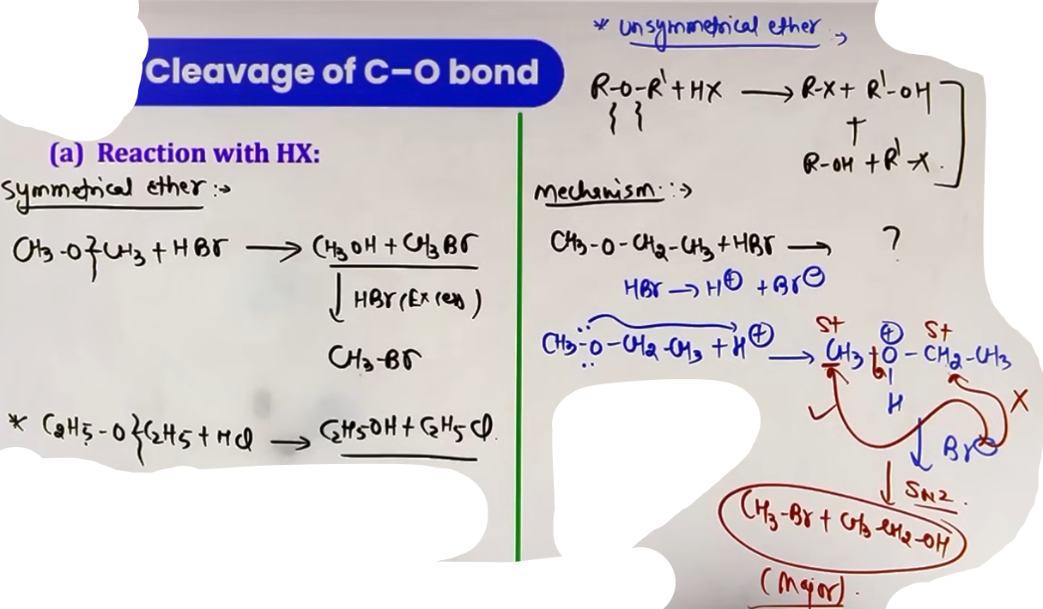
1. SN2 Pathway (The Standard Case):
- Occurs when both alkyl groups are 1-degree or 2-degree.
- Step 1: Protonation of oxygen.
- Step 2: The halide ion (X-) attacks the LESS sterically hindered (smaller) alkyl group.
- Product: Smaller alkyl group becomes Alkyl Halide; larger group remains an Alcohol.

2. SN1 Pathway (The Stable Cation Case):
- Occurs if one of the alkyl groups is 3-degree, Benzylic, or Allylic.
- Step 1: Protonation of oxygen.
- Step 2: The C-O bond breaks first to form a stable carbocation.
- Step 3: The halide ion (X-) attacks the carbocation.
- Product: The group that forms the stable cation becomes the Alkyl Halide.
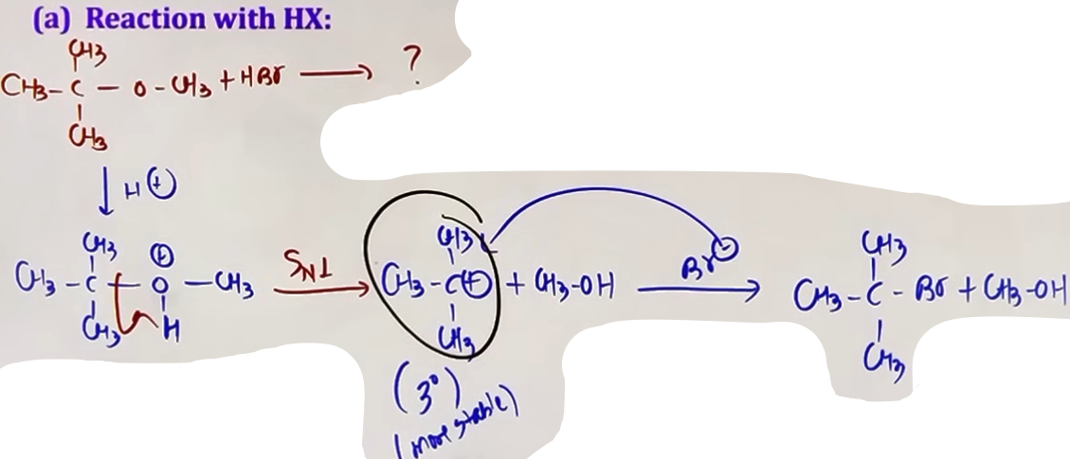
# Sn1 bhi ho sakti h aur Sn2 bhi apne vivek se kaam lena padega.

Anisole -
- When reacted with HX, it ALWAYS yields Phenol and Methyl Halide.
- Reasoning: The bond between the benzene ring and oxygen has partial double bond character due to resonance and is too strong to break. The cleavage only happens at the alkyl-oxygen bond.
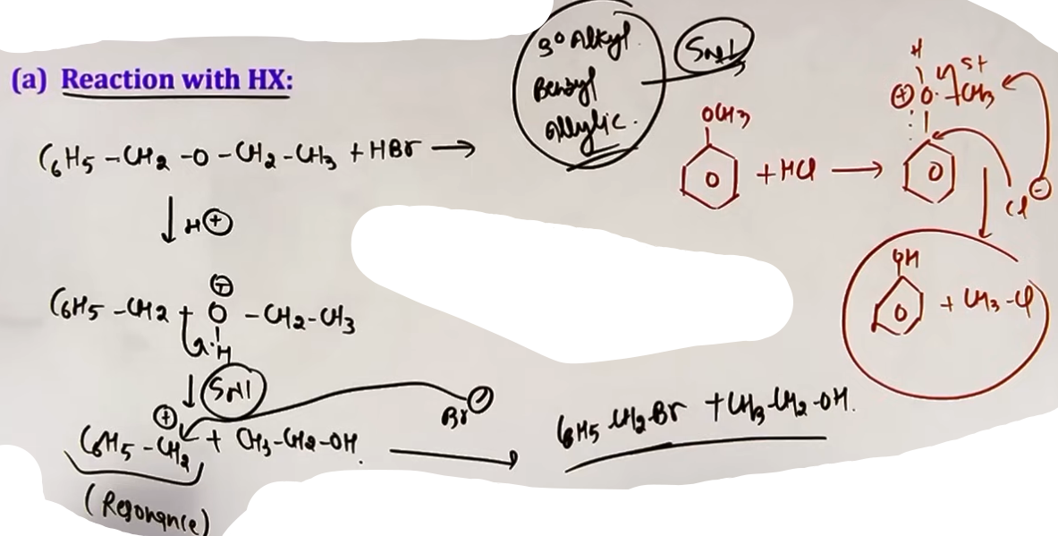
ACIDIC HYDROLYSIS
- Ethers are stable in basic and neutral media but can be hydrolyzed in acidic media (H2O / H+).
- Mechanism: Identical logic to HX cleavage (SN1 vs SN2). One side becomes an alcohol, the other becomes another alcohol. #same as HX
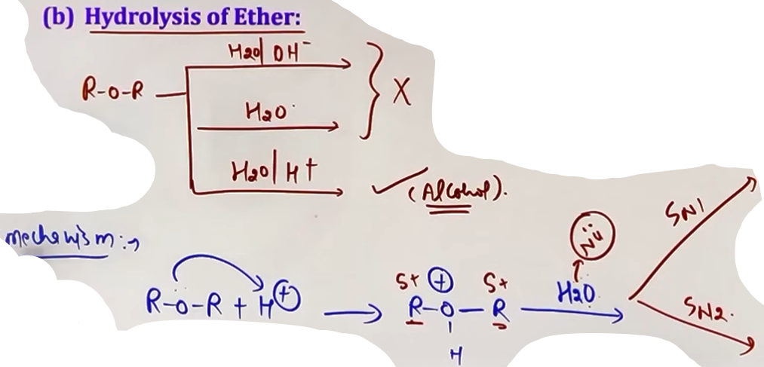
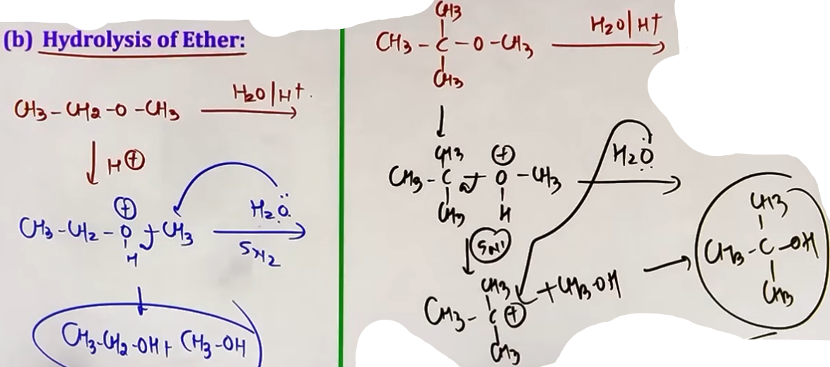

ELECTROPHILIC SUBSTITUTION
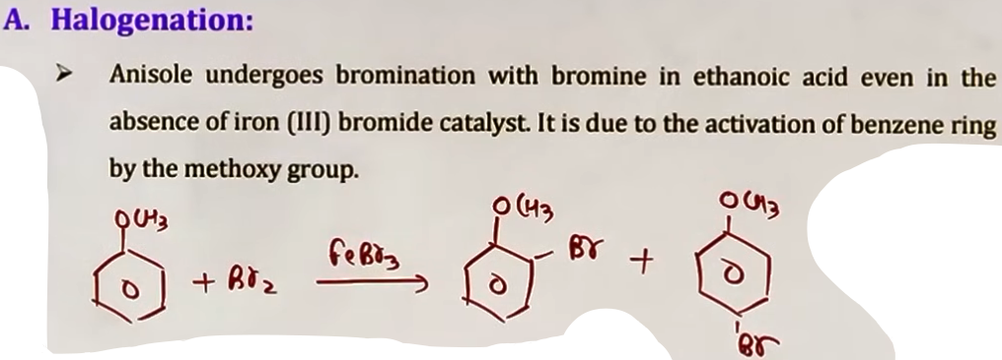
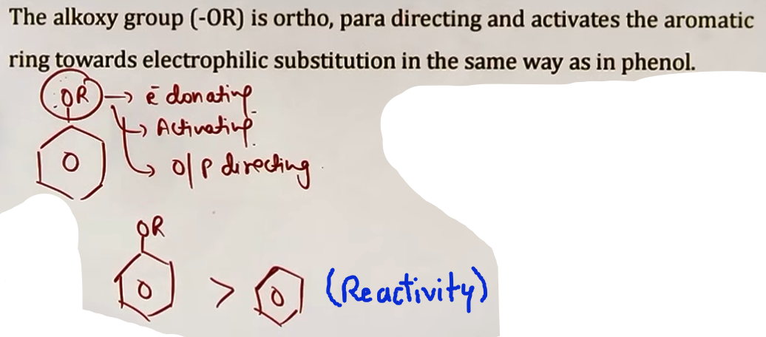
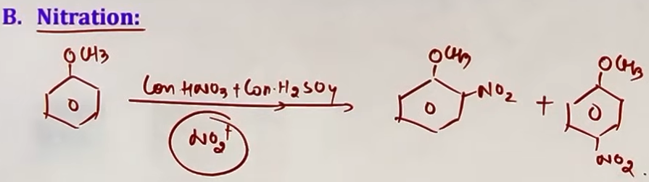
# ek friedel craft bhi h vo karai nahi hw de di :(
EPOXIDES (JEE SPECIFIC NOT IN BOARDS)
Epoxides are 3-membered cyclic ethers (Oxiranes). They are highly reactive due to extreme angle strain (60 degree bond angles instead of 109.28).

METHODS OF PREPARATION (MOP)

A. FROM HALOHYDRINS
- Reaction: Treatment of halohydrins (adjacent C-OH and C-X) with a base like NaOH.
- Mechanism: Internal SN2 reaction. The base deprotonates the OH to O-, which then attacks the carbon holding the halogen from the opposite side.
- Requirement: The OH and X groups must be in an ANTI-position to each other for the internal attack to occur.
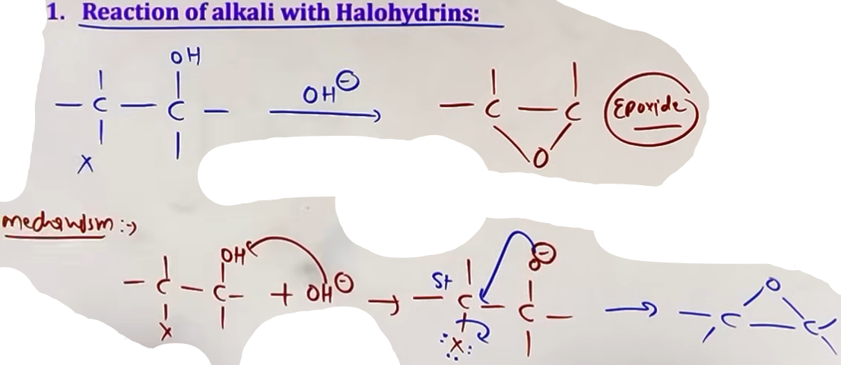
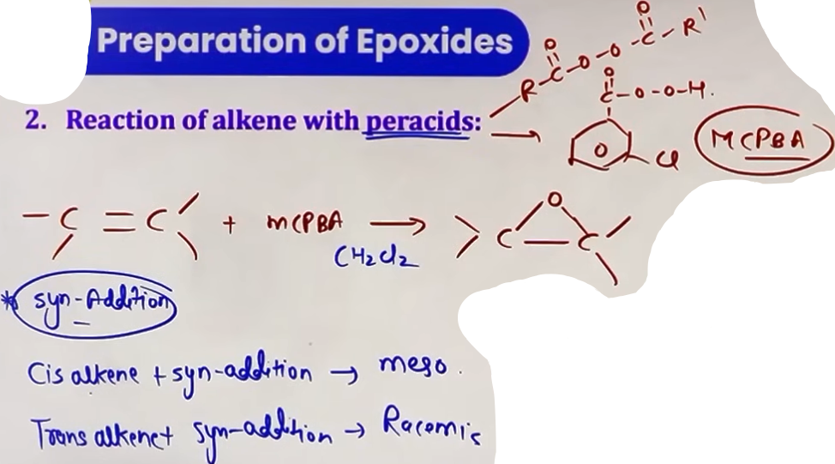
B. VIA MCPBA (PERACID OXIDATION)
- Reagent: MCPBA (Meta-chloroperbenzoic acid) or other peracids.
- Process: The peracid adds an oxygen atom across the double bond of an alkene.
- Stereochemistry: This is a SYN-addition. The stereochemistry of the alkene is retained (Cis-alkene yields Cis-epoxide/Meso; Trans-alkene yields Trans-epoxide/Racemic).

CHEMICAL PROPERTIES
RING-OPENING REACTIONS: REGIOSPECIFICITY
The high angle strain makes epoxides susceptible to nucleophilic attack, which opens the ring. The site of attack depends on the medium:

1. BASIC MEDIUM (OR NEUTRAL)
- Mechanism: Pure SN2.
- Regiospecificity: The nucleophile attacks the LESS substituted (less hindered) carbon.
- Reasoning: Steric hindrance is the dominant factor.

2. ACIDIC MEDIUM
- Mechanism: SN1-like (borderline SN2/SN1).
- Regiospecificity: The nucleophile attacks the MORE substituted carbon.
- Reasoning: In acidic conditions, the oxygen is protonated, creating a partial positive charge on the carbons. The more substituted carbon can better stabilize this partial positive charge, making it more electrophilic and attractive to the nucleophile.

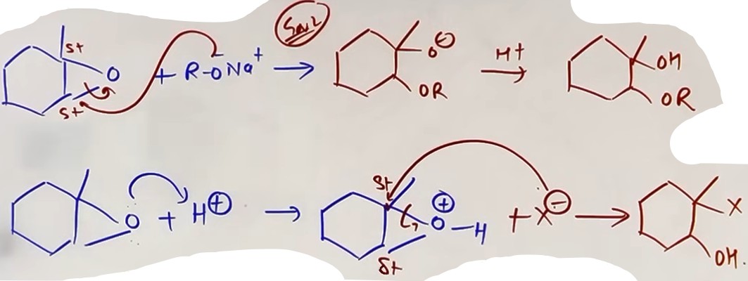
INTUITION AND CONCEPTUAL UNDERSTANDING
MENTAL MODEL FOR WILLIAMSON
Think of the alkoxide as a "bulky hunter." It can be big and heavy (3-degree), but it needs an easy, uncrowded target (1-degree halide). If the target is too crowded (3-degree halide), the hunter gets frustrated and just steals a hydrogen instead (Elimination).

VISUALIZING EPOXIDE RING OPENING
Imagine the epoxide as a "spring-loaded trap" held by a thin wire (the C-O bonds).
- In base, you touch the wire that is easiest to reach (less hindered carbon).
- In acid, the "acid" weakens the stronger wire (more substituted carbon because it handles the charge better), causing that one to snap when touched.

PROBLEM-SOLVING FRAMEWORK
QUESTION TYPE | IDENTIFICATION CLUES | APPROACH / STRATEGY
Williamson Product | R-X + R'-ONa | Check R-X. 1-deg = Ether.  2/3-deg = Alkene (Major).
Cleavage by HX | Ether + HI/HBr | Look for 3-deg/Benzyl.  Yes = SN1; No = SN2 (Small R).
Epoxide in Acid | H+ / Nu- | Attack MORE substituted carbon.
Epoxide in Base | Strong Nu- (e.g., NaOCH3) | Attack LESS substituted carbon.

JEE ADVANCED INSIGHTS
- SOLVENT EFFECTS: In Williamson synthesis, using polar aprotic solvents (like DMSO) enhances the nucleophilicity of the alkoxide and speeds up the SN2 reaction.
- HI VS HBR: HI is generally more reactive in ether cleavage because I- is a better nucleophile than Br-.
- DIBAL-H: While not directly an ether reaction, remember that ethers are often used as inert solvents for aggressive reagents like DIBAL-H or LiAlH4.

HIGH-YIELD REVISION SHEET
MUST REMEMBER:
- Williamson: Alkyl Halide must be 1-degree.
- Ether BP: Lower than Alcohols (no self-H-bonding).
- HI Cleavage SN2: I- goes to the smaller group.
- HI Cleavage SN1: I- goes to the 3-degree/Benzyl group.
- Epoxide Acid: Nu- to More Substituted C.
- Epoxide Base: Nu- to Less Substituted C.

LAST-MINUTE REVISION POINTS:
- Ethers can H-bond with water (soluble) but not with themselves.
- Phenyl ethers (Anisole) do not give aryl halides with HX.
- MCPBA makes epoxides via a syn-addition mechanism.
- Ethylene glycol (Dihydric) is more soluble than simple ethers.

♗♗♗♗♗♗♗♗♗♗♗♗♗♗♗♗♗♗♗♗♗♗♗♗♗♗♗♗♗♗♗♗♗♗♗♗♗♗♗♗♗♗♗♗♗♗♗♗♗♗♗♗♗♗♗♗♗♗♗♗♗♗♗♗♗♗♗♗♗♗♗♗♗♗♗♗♗♗♗♗
Match List−I with List−II:
 | List−I  (Chemicals) |  | List−II  (Use / Preparation / Constituent)
(a) | Alcoholic potassium hydroxide | (i) | Electrodes in batteries
(b) | Pd/BaSO4 | (ii) | Obtained by addition reaction
(c) | BHC (Benzene hexachloride) | (iii) | Used for β−elimination reaction
(d) | Polyacetylene | (iv) | Lindlar's catalyst
Choose the most appropriate match -
a-iii, b-iv, c-ii, d-ii

--------------------------------------------------------------------------------

- phenol NaOH k sath react karta h aur alcohol nahi kafi bar pucha gaya h.
- reimer-tiemann rxn k intermediate ki structure kai baar puchi h
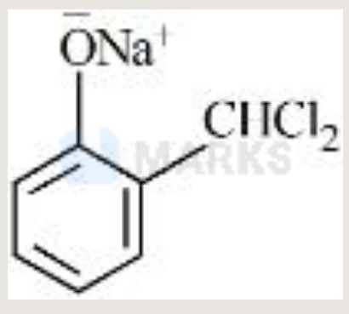
- phenol on reacting with H2SO4 gives phenol-2,4-disulphonic acid.
- bromination of phenol doesn’t require an lewis acid catalyst bcoz phenol is an highly activated compound.
- Reimer-Tiemann rxn p bahut question aaye h ki salicyaldehyde kaise banaye ya reagents kya h.

